trator, and font representation schemes, such as that used in Postscript, use cubic Be´zier curves. Be´zier curves are extremely popular in computer graphics because they are easy to control, have a number of useful properties, and there are very efficient algorithms for working with them.

Be´zier curves are constructed such that:

* The curve interpolates the first and last control points, with *u* = 0 and 1, respectively.
* The first derivative of the curve at its beginning (end) is determined by the vector between the first and second (next to last and last) control points. The derivatives are given by the vectors between these points scaled by the degree of the curve.
* Higher derivatives at the beginning (end) of the curve depend on the points at the beginning (end) of the curve. The *nth* derivative depends on the first (last) *n* +1 points.

For example, consider the Be´zier curve of degree 3 (cubic) as in Figure 15.10. The curve has four (*d* + 1) control points. It begins at the first control point (**p**0)

and ends at the last (**p**1). The first derivative at the beginning is proportional to the vector between the first and second control points (**p**1 *−* **p**0). Specifically, **f** *j*(0) = 3(**p**1 *−* **p**0). Similarly, the first derivative at the end of the curve is given by **f** *j*(1) = 3(**p**3 *−* **p**2). The second derivative at the beginning of the curve can be determined from control points **p**0, **p**1 and **p**2.

Using the facts about Be´zier cubics in the preceding paragraph, we can use the methods of Section 15.5 to create a parametric function for them. The definitions

**p**1



**p**2

**f**’(0)=3(**p**1 – **p**0)

**p**0

**p**3

**f**’(1)=3(**p**3 – **p**2)

**Figure 15.10.** A cubic Be´zier curve is controlled by four points. It interpolates the first and last, and the beginning and final derivatives are three times the vectors between the first two (or last two) points.

of the beginning and end interpolation and derivatives give

**p**0 = **f** (0) = **a**303 + **a**202 + **a**10+ **a**0*,*

**p**3 = **f** (1) = **a**313 + **a**212 + **a**11+ **a**0*,* 3(**p**1 *−* **p0**) = **f** *j*(0) = 3**a**302 + 2**a**20+ **a**1*,*

3(**p**3 *−* **p**2) = **f** *j*(1) = 3**a**312 + 2**a**21+ **a**1*.*

This can be solved for the basis matrix

|  |  |  |  |
| --- | --- | --- | --- |
| 1 | 0 | 0 | 0 |
| *−*3 | 3 | 0 | 0 |

and then written as

**B** = **C***−*1 = ⎡⎢⎣

3 *−*6 3 0

*−*1 3 *−*3 1

⎤⎥⎦ *,*

**f** (*u*) = (1 *−* 3*u* + 3*u*2 *−u*3)**p**0 + (3*u −* 6*u*2 + 3*u*3)**p**1 + (3*u*2 *−* 3*u*3)**p**2 + (*u*3)**p**3*,*

or

*d*

Σ

**f** (*u*) = *bi,*3**p***i,*

*i*=0

where the *bi,*3 are the Be´zier blending functions of degree 3:

*b*0*,*3 = (1 *u*)3*,*

*−*

*b*1*,*3 = 3*u*(1 *u*)2*,*

*−*

*b*2*,*3 = 3*u*2(1 *u*)*, b*3*,*3 = *u*3*.*

*−*

Fortunately, the blending functions for Be´zier curves have a special form that works for all degrees. These functions are known as the *Bernstein basis polyno- mials* and have the general form

*bk,n*(*u*) = *C*(*n, k*) *uk* (1 *− u*)(*n−k*)*,*

where *n* is the order of the Be´zier curve, and *k* is the blending function number between 0 and *n* (inclusive). *C*(*n, k*) are the binomial coefficients:

*n*!

*C*(*n, k*) =

*.*

*k*! (*n − k*)!

Given the positions of the control points **p***k,* the function to evaluate the Be´zier curve of order *n* (with *n* +1 control points) is

*n*

Σ

**p**(*u*) =

*pkC*(*n, k*) *uk* (1 *− u*)(*n−k*)*.*

*k*=0

Some Be´zier segments are shown in Figure 15.11.

**Figure 15.11.** Various Be´zier segments of degree 2–6. The control points are shown with crosses, and the control polygons (line segments connecting the control points) are also shown.

Be´zier segments have several useful properties:

* The curve is bounded by the convex hull of the control points.
* Any line intersects the curve no more times than it intersects the set of line segments connecting the control points. This is called the *variation diminishing* property. This property is illustrated in Figure 15.12.
* The curves are symmetric: reversing the order of the control points yields the same curve, with a reversed parameterization.
* The curves are *affine invariant.* This means that translating, scaling, rotat- ing, or skewing the control points is the same as performing those opera- tions on the curve itself.
* There are good simple algorithms for evaluating and subdividing Be´zier curves into pieces that are themselves Be´zier curves. Because subdivision

**Figure 15.12.** The *variation diminishing* property of Be´zier curves means that the curve does not cross a line more than its control polygon does. Therefore, if the control polygon has no “wiggles,” the curve will not have them either. B-splines (Section 15.6.2) also have this property.

can be done effectively using the algorithm described later, a divide and conquer approach can be used to create effective algorithms for important tasks such as rendering Be´zier curves, approximating them with line seg- ments, and determining the intersection between two curves.

When Be´zier segments are connected together to make a spline, connectivity be- tween the segments is created by sharing the endpoints. However, continuity of the derivatives must be created by positioning the other control points. This provides the user of a Be´zier spline with control over the smoothness. For *G*1 continuity, the second-to-last point of the first curve and the second point of the second curve must be collinear with the equated endpoints. For *C*1 continu- ity, the distances between the points must be equal as well. This is illustrated

in Figure 15.13. Higher degrees of continuity can be created by properly posi- tioning more points.

Geometric Intuition for Be´zier Curves

Be´zier curves can be derived from geometric principles, as well as from the alge- braic methods described above. We outline the geometric principles because they provides intuition on how Be´zier curves work.

Imagine that we have a set of control points from which we want to create a smooth curve. Simply connecting the points with lines (to form the control polygon) will lead to something that is non-smooth. It will have sharp corners. We could imagine “smoothing” this polygon by cutting off the sharp corners, yielding a new polygon that is smoother, but still not “smooth” in the mathematical sense

(since the curve is still a polygon, and therefore only *C*1). We can repeat this process, each time yielding a smoother polygon, as shown in Figure 15.14. In the limit, that is if we repeated the process infinitely many times, we would obtain a *C*1 smooth curve.



**Figure 15.13.** Two Be´zier segments connect to form a *C*1 spline, because the vector be- tween the last two points of the first segment is equal to the vector between the first two points of the second segment.



**Figure 15.14.** Subdivision procedure for quadratic Be´ziers. Each line segment is divided in half and these midpoints are connected (blue points and lines). The interior control point is moved to the midpoint of the new line segment (orange point).

**Figure 15.15.** By repeatedly cutting the corners off a polygon, we approach a smooth curve.

What we have done with corner cutting is defining a *subdivision* scheme. That is, we have defined curves by a process for breaking a simpler curve into smaller pieces (e.g., subdividing it). The resulting curve is the *limit curve* that is achieved by applying the process infinitely many times. If the subdivision scheme is de- fined correctly, the result will be a smooth curve, and it will have a parametric form.

Let us consider applying corner cutting to a single corner. Given three points (**p**0*,* **p**1*,* **p**2), we repeatedly “cut off the corners” as shown in Figure 15.15. At each step, we divide each line segment in half, connect the midpoints, and then move the corner point to the midpoint of the new line segment. Note that in this

process, new points are introduced, moved once, and then remain in this position for any remaining iterations. The endpoints never move.

If we compute the “new” position for **p**2 as the midpoint of the midpoints, we get the expression

**p***j*2

1 1

= 2 ( 2 **p**0 +

1 1 1

2 **p**1)+ 2 ( 2

**p**1 +

1

2 **p**2)*.*

The construction actually works for other proportions of distance along each segment. If we let *u* be the distance between the beginning and the end of each segment where we place the middle point, we can rewrite this expression as

**p**(*u*) = (1 *− u*)((1 *− u*)**p**0 + *u***p**1)+ *u*((1 *− u*)**p**1 + *u***p**2)*.*

Regrouping terms gives the quadratic Be´zier function:

**B**2(*u*) = (1 *− u*)2**p**0 + 2*u*(1 *− u*)**p**1 + *u*2**p**2*.*

The de Casteljau Algorithm

One nice feature of Be´zier curves is that there is a very simple and general method for computing and subdividing them. The method, called the *de Casteljau algo- rithm,* uses a sequence of linear interpolations to compute the positions along the

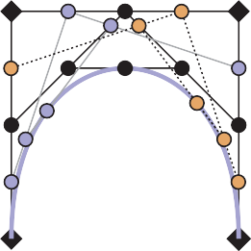

2

3

2

3

1

4

1

4

**Figure 15.16.** An illustration of the de Casteljau algorithm for a cubic Be´zier. The left-hand image shows the construction for *u* = 0.5*.* The right-hand image shows the construction for 0.25, 0.5, and 0.75.

Be´zier curve of arbitrary order. It is the generalization of the subdivision scheme described in the previous section.

The de Casteljau algorithm begins by connecting every adjacent set of points with lines, and finding the point on these lines that is the *u* interpolation, giving a

set of *n−* 1 points. These points are then connected with straight lines, those lines are interpolated (again by *u*), giving a set of *n−* 2 points. This process is repeated until there is one point. An illustration of this process is shown in Figure 15.16.

The process of computing a point on a Be´zier segment also provides a method for dividing the segment at the point. The intermediate points computed during the de Casteljau algorithm form the new control points of the new, smaller seg- ments, as shown in Figure 15.17.

The existence of a good algorithm for dividing Be´zier curves makes divide- and-conquer algorithms possible. For example, when drawing a Be´zier curve



B

BC

C

AC AD BD

AB

CD

A

D

**Figure 15.17.** The de Casteljau algorithm is used to subdivide a cubic Be´zier segment. The initial points (black diamonds A, B, C, and D) are linearly interpolated to yield blue circles (AB, BC, CD), which are linearly interpolated to yield orange circles (AC, BD), which are linearly interpolated to give the point on the cubic AD. This process also has subdivided the Be´zier segment with control points A,B,C,D into two Be´zier segments with control points A, AB, AC, AD and AD, BD, CD, D.

segment, it is easy to check if the curve is close to being a straight line because it is bounded by its convex hull. If the control points of the curve are all close to being colinear, the curve can be drawn as a straight line. Otherwise, the curve can be divided into smaller pieces, and the process can be repeated. Similar algorithms can be used for determining the intersection between two curves. Because of the existence of such algorithms, other curve representations are often converted to Be´zier form for processing.

* + 1. B-Splines

B-splines provide a method for approximating a set of *n* points with a curve made up of polynomials of degree *d* that gives *C*(*d−*1) continuity. Unlike the Be´zier splines of the previous section, B-splines allow curves to be generated for any desired degree of continuity (almost up to the number of points). Because of this, B-splines are a preferred way to specify very smooth curves (high degrees of continuity) in computer graphics. If we want a *C*2 or higher curve through an arbitrary number of points, B-splines are probably the right method.

We can represent a curve using a linear combination of B-spline basis func- tions. Since these basis functions are themselves splines, we call them basis splines or B-splines for short. Each B-spline or basis function is made up of a set of *d* + 1 polynomials each of degree *d.* The methods of B-splines provide

general procedures for defining these functions.

The term B-spline specifically refers to one of the basis functions, not the function created by the linear combination of a set of B-splines. However, there is inconsistency in how the term is used in computer graphics. Commonly, a “B- spline curve” is used to mean a curve represented by the linear combination of B-splines.

The idea of representing a polynomial as the linear combination of other poly- nomials has been discussed in Section 15.3.1 and 15.3.5. Representing a spline as a linear combination of other splines was shown in Section 15.4.1. In fact, the example given is a simple case of a B-spline.

The general notation for representing a function as a linear combination of other functions is

Σ

*n*

**f** (*t*) = **p***ibi*(*t*)*,* (15.15)

*i*=1

where the **p***i* are the coefficients and the *bi* are the basis functions. If the coeffi- cients are points (e.g., 2 or 3 vectors), we refer to them as control points. The key to making such a method work is to define the *bi* appropriately. B-splines provide a very general way to do this.

A set of B-splines can be defined for a number of coefficients *n* and a param- eter value *k.*3 The value of *k* is one more than the degree of the polynomials used to make the B-splines (*k* = *d* + 1*.*)

B-splines are important because they provide a very general method for cre-

ating functions (that will be useful for representing curves) that have a number of useful properties. A curve with *n* points made with B-splines with parameter value *k*:

* is *C*(*k−*2) continuous;
* is made of polynomials of degree *k −* 1;
* has local control—any site on the curve only depends on *k* of the control points;
* is bounded by the convex hull of the points;
* exhibits the variation diminishing property illustrated in Figure 15.12.

A curve created using B-splines does not necessarily interpolate its control points. We will introduce B-splines by first looking at a specific, simple case to in- troduce the concepts. We will then generalize the methods and show why they are interesting. Because the method for computing B-splines is very general, we

delay introducing it until we have shown what these generalizations are.

Uniform Linear B-Splines

Consider a set of basis functions of the following form:

*bi,*2(*t*) =

2 *− t* + *i* if *i* +1 *≤ t ≤ i* + 2*,*

⎩0 otherwise*.*

⎧⎪⎨*t − i* if *i ≤ t < i* + 1*,*

(15.16)

Each of these functions looks like a little triangular “hat” between *i* and *i* +2 with its peak at *i* + 1*.* Each is a piecewise polynomial, with knots at *i*, *i* + 1, and *i* + 2*.* Two of them are graphed in Figure 15.18.

⎪

Each of these functions *bi,*2 is a first-degree (linear) B-spline. Because we will consider B-splines of other parameter values later, we denote these with the 2 in the subscript.

3 The B-spline parameter is actually the *order* of the polynomials used in the B-splines. While this terminology is not uniform in the literature, the use of the B-spline parameter *k* as a value one greater than the polynomial degree is widely used, although some texts (see the chapter notes) write all of the equations in terms of polynomial degree.

1

*b*1,2(*t*)

1

*b*2,2(*t*)

00

1

2

3

4

00

1

2

3

4

**Figure 15.18.** B-splines with *d* = 1 or *k* = 2.

Notice that we have chosen to put the lower edge of the B-spline (its first knot) at *i*. Therefore, the first knot of the first B-spline (*i* = 1) is at 1. Iteration over the B-splines or elements of the coefficient vector is from 1 to *n* (see Equation 15.15). When B-splines are implemented, as well as in many other discussions of them, they often are numbered from 0 to *n −* 1*.*

We can create a function from a set of *n* control points using Equation 15.15,

with these functions used for the *bi* to create an “overall function” that was influ- enced by the coefficients. If we were to use these (*k* = 2) B-splines to define the overall function, we would define a piecewise polynomial function that linearly interpolates the coefficients **p***i* between *t* = *k* and *t* = *n* + 1*.* Note that while (*k* = 2) B-splines interpolate all of their coefficients, B-splines of higher degree do this under some specific conditions that we will discuss in Section 15.6.3.

Some properties of B-splines can be seen in this simple case. We will write these in the general form using *k*, the parameter, and *n* for the number of coeffi- cients or control points:

* + Each B-spline has *k* +1 knots.
  + Each B-spline is zero before its first knot and after its last knot.
  + The overall spline has local control because each coefficient is only mul- tiplied by one B-spline, and this B-spline is nonzero only between *k* + 1 knots.
  + The overall spline has *n* + *k* knots.
  + Each B-spline is *C*(*k−*2) continuous, therefore the overall spline is *C*(*k−*2)

continuous.

* + The set of B-splines sums to 1 for all parameter values between knots *k* and *n* + 1*.* This range is where there are *k* B-splines that are nonzero. Summing to 1 is important because it means that the B-splines are shift invariant: translating the control points will translate the entire curve.
* Between each of its knots, the B-spline is a single polynomial of degree *d* = *k −* 1. Therefore, the overall curve (that sums these together) can also be expressed as a single, degree *d* polynomial between any adjacent knots.

In this example, we have chosen the knots to be uniformly spaced. We will con- sider B-splines with nonuniform spacing later. When the knot spacing is uniform, each of the B-splines is identical except for being shifted. B-splines with uniform knot spacing are sometimes called *uniform B-splines* or *periodic B-splines*.

Uniform Quadratic B-Splines

The properties of B-splines listed in the previous section were intentionally writ- ten for arbitrary *n* and *k*. A general procedure for constructing the B-splines will be provided later, but first, lets consider another specific case with *k* = 3*.*

The B-spline *b*2*,*3 is shown in Figure 15.19. It is made of quadratic pieces

(degree 2), and has three of them. It is *C*1 continuous and is nonzero only within the four knots that it spans. Notice that a quadratic B-spline is made of three pieces, one between knot 1 and 2, one between knot 2 and 3, and one between

knot 3 and 4. In Section 15.6.3 we will see a general procedure for building these functions. For now, we simply examine these functions:

⎧**⎪** 1 *u*2 if *i ≤ t < i* +1 *u* = *t − i,*

2

⎪⎨*−u*2 + *u* + 1 if *i* +1 *≤ t < i* +2 *u* = *t −* (*i* + 1)*,*

2 (1 *− u*) if *i* +2 *≤ t < i* +3 *u* = *t −* (*i* + 2)*,*

**⎪**⎩

*bi,*3(*t*) =

1

2

2

(15.17)

0 otherwise*.*

In order to make the expressions simpler, we wrote the function for each part as if it applied over the range 0 to 1.

If we evaluate the overall function made from summing together the B-splines,

at any time only *k* (3 in this case) of them are nonzero. One of them will be in the first part of Equation 15.17, one will be in the second part, and one will be in the third part. Therefore, we can think of any piece of the overall function as being

1

0

0

1

2

3

4

5

**Figure 15.19.** The B-spline *b*2,3 with uniform knot spacing.

1

00

1

2

3

4

5

6

7

8

9 10

**Figure 15.20.** The set of seven B-splines with *k* = 3 and uniform knot spacing [1, 2, 3, 4, 5, 6, 7, 8, 10].

made up of a degree *d* = *k −* 1 polynomial that depends on *k* coefficients. For the *k* = 3 case, we can write

2

**f** (*u*) = 1 (1 *u*)2**p**

*−*

2 *i*

+ (*−u*

1

+ *u* + 2 )**p***i*+1

1

+ *u* **p**

2

2

*i*+2

where *u* = *t−i.* This defines the piece of the overall function when *i ≤ t < i*+1*.*

If we have a set of *n* points, we can use the B-splines to create a curve. If we

have seven points, we will need a set of seven B-splines. A set of seven B-splines for *k* = 3 is shown in Figure 15.20. Notice that there are *n* + *k* (10) knots, that the sum of the B-splines is 1 over the range *k* to *n* + 1 (knots 3 through 8). A curve specified using these B-splines and a set of points is shown in Figure 15.21.

Uniform Cubic B-Splines

Because cubic polynomials are so popular in computer graphics, the special case of B-splines with *k* = 4 is sufficiently important that we consider it before dis- cussing the general case. A B-spline of third degree is defined by four cubic polynomial pieces. The general process by which these pieces are determined is

3

5

2

4

6

1

7

**Figure 15.21.** Curve made from seven quadratic (*k*=3) B-splines, using seven control points.

2

3

*b*1(*t* – 1)

*b*2(*t* – 2)

*b*0(*t*)

*b*3(*t* – 3)

*t* = *i*

*t* = *i* + 1

*t* = *i* + 2

*t* = *i* + 3

*t* = *i* + 4

**Figure 15.22.** The cubic (*k* = 4) B-spline with uniform knots.

described later, but the result is

⎧**⎪** *u* if *i ≤ t < i* +1 *u* = *t − i,*

1 3

6

⎨ 6

1 (3*u*3 *−* 6*u*2 + 4) if *i* +2 *≤ t < i* +3 *u* = *t −* (*i* + 2)*,*

**⎪** 1 (*−*3*u*3 + 3*u*2 + 3*u* + 1) if *i* +1 *≤ t < i* +2 *u* = *t −* (*i* + 1)*,*

*bi,*4(*t*) =

6

1 (*−u*3 + 3*u*2 *−* 3*u* + 1) if *i* +3 *≤ t < i* +4 *u* = *t −* (*i* + 3)*,*

(15.18)

6

This degree 3 B-spline is graphed for *i* = 1 in Figure 15.22.

We can write the function for the overall curve between knots *i* +3 and *i* +4 as a function of the parameter *u* between 0 and 1 and the four control points that influence it:

**⎪**

**⎪**⎩0 otherwise*.*

1 3

**f** (*u*) = 6 (*−u*

+ 3*u*2

1 3

*−* 3*u* + 1)**p***i* + 6 (3*u*

*−* 6*u*

+ 4)**p***i*+1

1 3 2 1 3

2

+ 6 (*−*3*u* + 3*u* + 3*u* + 1)**p***i*+2 + 6 *u* **p***i*+3*.*

This can be rewritten using the matrix notation of the previous sections, giving a basis matrix for cubic B-splines of

**M** = 1 ⎡⎢

⎣6

**b**

*−*1 3 *−*3 1

3 6 3 0 *.*

⎥

⎥⎦

⎤

*−*

*−*

3 0 3 0

1 4 1 0

Unlike the matrices that were derived from constraints in Section 15.5, this ma- trix is created from the polynomials that are determined by the general B-spline procedure defined in the next section.

*k* = 2

*k* = 4

*k* = 3

*k* = 5

**Figure 15.23.** B-spline curves using the same uniform set of knots and the same control points, for various values of *k*. Note that as *k* increases, the valid parameter range for the curve shrinks.

* + 1. Nonuniform B-Splines

One nice feature of B-splines is that they can be defined for any *k >* 1*.* So if we need a smoother curve, we can simply increase the value of *k.* This is illustrated in Figure 15.23.

So far, we have said that B-splines generalize to any *k >* 1 and any *n ≥ d.*

There is one last generalization to introduce before we show how to actually com-

pute these B-splines. B-splines are defined for any non-decreasing knot vector.

For a given *n* and *k,* the set of B-splines (and the function created by their linear combination) has *n* + *k* knots. We can write the value of these knots as a vector, that we will denote as **t***.* For the uniform B-splines, the knot vector is [1*,* 2*,* 3*,...,n* + *k*]*.* However, B-splines can be generated for any knot vector of

length *n* + *k,* providing the values are non-decreasing (e.g., *ti*+1 *≥ ti*).

There are two main reasons why nonuniform knot spacing is useful: it gives us

control over what parameter range of the overall function each coefficient affects, and it allows us to repeat knots (e.g., create knots with no spacing in between) in order to create functions with different properties around these points. The latter will be considered later in this section.

The ability to specify knot values for B-splines is similar to being able to spec- ify the interpolation sites for interpolating spline curves. It allows us to associate curve features with parameter values. By specifying a nonuniform knot vector, we specify what parameter range each coefficient of a B-spline curve affects. Re-

member that B-spline *i* is nonzero only between knot *i* and knot *i* + *k.* Therefore, the coefficient associated with it only affects the curve between these parameter

values.

One place where control over knot values is particularly useful is in inserting or deleting knots near the beginning of a sequence. To illustrate this, consider a

curve defined using linear B-splines (*k* = 2) as discussed in Section 15.6.2. For *n* = 4*,* the uniform knot vector is [1*,* 2*,* 3*,* 4*,* 5*,* 6]*.* This curve is controlled by a set of four points and spans the parameter range *t* = 2 to *t* = 5*.* The “end” of the curve (*t* = 5) interpolates the last control point. If we insert a new point in

the middle of the point set, we would need a longer knot vector. The locality properties of the B-splines prevent this insertion from affecting the values of the curve at the ends. The longer curve would still interpolate its last control point at its end. However, if we chose to keep the uniform knot spacing, the new knot vector would be [1*,* 2*,* 3*,* 4*,* 5*,* 6*,* 7]. The end of the curve would be at *t* = 6*,* and the

parameter value at which the last control point is interpolated will be a different

parameter value than before the insertion. With nonuniform knot spacing, we can use the knot vector [1*,* 2*,* 3*,* 3*.*5*,* 4*,* 5*,* 6] so that the ends of the curve are unaffected by the change. The abilities to have nonuniform knot spacing makes the locality property of B-splines an algebraic property, as well as a geometric one.

We now introduce the general method for defining B-splines. Given values for the number of coefficients *n,* the B-spline parameter *k*, and the knot vector **t** (which has length *n* + *k*), the following recursive equations define the B-splines:

*bi,*1*,***t**

1. = 1 if **t***i ≤ t <* **t***i*+1*,*

0 otherwise*.*

.

(15.19)

*bi,k,***t**(*t*) = *t−***t***i bi,k−*1(*t*)+ **t***i*+*k−t bi*+1*,k−*1(*t*)*.* (15.20)

**t***i*+*k−*1 *−***t***i* **t***i*+*k−***t***i*+1

This equation is know as the *Cox–de Boor recurrence*. It may be used to compute specific values for specific B-splines. However, it is more often applied alge- braically to derive equations such as Equation 15.17 or 15.18.

As an example, consider how we would have derived Equation 15.17. Using a uniform knot vector [1*,* 2*,* 3*,.. .*]*, ti* = *i*, and the value *k* = 3 in Equation 15.20 yields

*bi,*3

(*t*) = *t − i b*

(*i* + 2) *− i*

1

*i,*2

+ (*i* + 3) *− t b*

(*i* + 3) *−* (*i* + 1)

1

*i*+1*,*2

(15.21)

= 2 (*t − i*)*bi,*2 + 2 (*i* +3 *− t*)*bi*+1*,*2*.*

Continuing the recurrence, we must evaluate the recursive expressions:

*bi,*2

(*t*) = *t − i b*

(*i* +2 *−* 1) *− i*

*i,*1

+ (*i* + 2) *− t b*

(*i* + 2) *−* (*i* + 1)

*i*+1*,*1

= (*t − i*)*bi,*1 + (*i* +2 *− t*)*bi*+1*,*1*,*

*bi*+1*,*2

(*t*) = *t −* (*i* + 1) *b* ((*i* + 1) +2 *−* 1) *−* (*i* + 1)

*i*+1*,*1

+ ((*i* + 1) + 2) *− t b*

((*i* + 1) + 2) *−* ((*i* + 1) + 1)

(*i*+1)+1*,*1

= (*t − i* + 1)*bi*+1*,*1 + (*i* +3 *− t*)*bi*+2*,*1*.*

Inserting these results into Equation 15.22 gives:

1

*bi,*3(*t*) = 2 (*t − i*)((*t − i*)*bi,*1 + (*i* +2 *− t*)*bi*+1*,*1)

1

+ 2 (*i* +3 *− t*)(*t − i* + 1)*bi*+1*,*1 + (*i* +3 *− t*)*bi*+2*,*1*.*

To see that this expression is equivalent to Equation 15.17, we note that each

of the (*k* = 1) B-splines is like a switch, turning on only for a particular parameter range. For instance, *bi,*1 is only nonzero between *i* and *i* + 1*.* So, if *i ≤ t < i* + 1*,* only the first of the (*k* = 1) B-splines in the expression is nonzero, so

1 2

*bi,*3(*t*) = 2 (*t − i*) if *i ≤ t < i* + 1*.*

Similar manipulations give the other parts of Equation 15.17.

Repeated Knots and B-Spline Interpolation

While B-splines have many nice properties, functions defined using them gener- ally do not interpolate the coefficients. This can be inconvenient if we are using them to define a curve that we want to interpolate a specific point. We give a brief overview of how to interpolate a specific point using B-splines here. A more complete discussion can be found in the books listed in the chapter notes.

One way to cause B-splines to interpolate their coefficients is to repeat knots. If all of the interior knots for a particular B-spline have the same value, then the overall function will interpolate this B-spline’s coefficient. An example of this is shown in Figure 15.24.

Interpolation by repeated knots comes at a high cost: it removes the smooth- ness of the B-spline and the resulting overall function and represented curve. However, at the beginning and end of the spline, where continuity is not an is- sue, knot repetition is useful for creating *endpoint interpolating B-splines.* While the first (or last) knot’s value is not important for interpolation, for simplicity, we make the first (or last) *k* knots have the same value to achieve interpolation.

Endpoint interpolating quadratic B-splines are shown in Figure 15.25. The

first two and last two B-splines are different than the uniform ones. Their expres-

* 1. Uniform knots (b) Nonuniform knots

**Figure 15.24.** A curve parameterized by quadratic B-splines (*k* = 3) with seven control points. On the left, uniform knots vector [1,2,3,4,5,6,7,8,9,10] is used. On the right, the nonuniform knot spacing [1,2,3,4,4,6,7,8,8,10] is used. The duplication of the 4th and 8th knot means that all interior knots of the 3rd and 7th B-spline are equal, so the curve interpolates the control point associated with those points.

sions can be derived through the use of the Cox–de Boor recurrence:

.(1 *− t*)2 if 0 *≤ t <* 1*,*

*b*1*,*3*,*[0*,*0*,*0*,*1*,*2*,...*](*t*) =

0 otherwise*.*

*b*2*,*3*,*[0*,*0*,*0*,*1*,*2*,...*](*t*) =

⎪

* + 1. NURBS

3 2

2

⎧⎪⎨2*u − u* if 0 *≤ t <* 1 *u* = *t,*

1 (1 *− u*)2 if 1 *≤ t <* 2 *u* = *t −* 1*,*

2

⎩0 otherwise*.*

Despite all of the generality B-splines provide, there are some functions that can- not be exactly represented using them. In particular, B-splines cannot represent conic sections. To represent such curves, a ratio of two polynomials is used. Nonuniform B-splines are used to represent both the numerator and the denom-

1

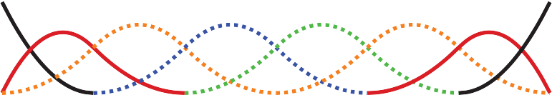

00 1 2 3 4 5 6

**Figure 15.25.** Endpoint interpolating quadratic (*k* = 3) B-splines, for *n* = 8. The knot vector is [0,0,0,1,2,3,4,5,6,6,6]. The first and last two B-splines are aperiodic, while the middle four (shown as dotted lines) are periodic and identical to the ones in Figure 15.20.

inator. The most general form of these are nonuniform rational B-splines, or NURBS for short.

NURBS associate a scalar weight *hi* with every control point **pi** and use the same B-splines for both:

**f** (*u*) =

*i i,k,***t**

*n i*=1

*n*

Σ

Σ

*i*=1

*hi***p***ibi,k,***t** *, h b*

where *bi,k,***t** are the B-splines with parameter *k* and knot vector **t***.*

NURBS are very widely used to represent curves and surfaces in geometric modeling because of the amazing versatility they provide, in addition to the useful properties of B-splines.

# 15.7 Summary

In this chapter, we have discussed a number of representations for free-form curves. The most important ones for computer graphics are:

* Cardinal splines use a set of cubic pieces to interpolate control points. They are generally preferred to interpolating polynomials because they are local and easier to evaluate.
* Be´zier curves approximate their control points and have many useful prop- erties and associated algorithms. For this reason, they are popular in graph- ics applications.
* B-spline curves represent the curve as a linear combination of B-spline functions. They are general and have many useful properties such as being bounded by their convex hull and being variation diminishing. B-splines are often used when smooth curves are desired.

# Notes

The problem of representing shapes mathematically is an entire field unto itself, generally known as geometric modeling. Representing curves is just the begin- ning and is generally a precursor to modeling surfaces and solids. A more thor- ough discussion of curves can be found in most geometric modeling texts, see for example *Geometric Modeling* (Mortenson, 1985) for a text that is accessible to computer graphics students. Many geometric modeling books specifically focus

on smooth curves and surfaces. Texts such as *An Introduction to Splines for Use in Computer Graphics* (Bartels, Beatty, & Barsky, 1987), *Curves and Surfaces for CAGD: A Practical Guide* (Farin, 2002) and *Geometric Modeling with Splines: An Introduction* (E. Cohen, Riesenfeld, & Elber, 2001) provide considerable detail about curve and surface representations. Other books focus on the mathematics of splines; *A Practical Guide to Splines* (De Boor, 2001) is a standard reference. The history of the development of curve and surface representations is com- plex, see the chapter by Farin in *Handbook of Computer Aided Geometric De- sign* (Farin, Hoschek, & Kim, 2002) or the book on the subject *An Introduction to NURBS: With Historical Perspective* (D. F. Rogers, 2000) for a discussion. Many ideas were independently developed by multiple groups who approached the problems from different disciplines. Because of this, it can be difficult to at- tribute ideas to a single person or to point at the “original” sources. It has also led to a diversity of notation, terminology, and ways of introducing the concepts in

the literature.

* + 1. Exercises

For Exercises 1–4, find the constraint matrix, the basis matrix, and the basis func- tions. To invert the matrices you can use a program such as MATLAB or OCTAVE (a free MATLAB-like system).

* + - 1. A line segment: parameterized with **p**0 located 25% of the way along the segment (*u* = 0*.*25), and **p**1 located 75% of the way along the segment.
      2. A quadratic: parameterized with **p**0 as the position of the beginning point (*u* = 0), **p**1, the first derivative at the beginning point, and **p**2, the second derivative at the beginning point.
      3. A cubic: its control points are equally spaced (**p**0 has *u* = 0*,* **p**1 has *u* = 1*/*3, **p**2 has *u* = 2*/*3, and **p**3 has *u* = 1).
      4. A quintic: (a degree five polynomial, so the matrices will be 6*×*6) where **p**0 is the beginning position, **p**1 is the beginning derivative, **p**2 is the middle (*u* = 0*.*5) position, **p**3 is the first derivative at the middle, **p**4 is the position

at the end, and **p**5 is the first derivative at the end.

* + - 1. The Lagrange form (Equation (15.12)) can be used to represent the inter- polating cubic of Exercise 3. Use it at several different parameter values to confirm that it does produce the same results as the basis functions derived in Exercise 3.
      2. Devise an arc-length parameterization for the curve represented by the para- metric function

*f* (*u*) = (*u, u*2)*.*

* + - 1. Given the four control points of a segment of a Hermite spline, compute the control points of an equivalent Be´zier segment.
      2. Use the de Casteljau algorithm to evaluate the position of the cubic Be´zier curve with its control points at (0,0), (0,1), (1,1) and (1,0) for parameter values *u* = 0*.*5 and *u* = 0*.*75*.* Drawing a sketch will help you do this.
      3. Use the Cox–de Boor recurrence to derive Equation (15.16).

# ikhmin

|  |  |  |
| --- | --- | --- |
|  | Micha | el Ash |
|  | 16 |  |
|  |  |  |

Computer Animation

*Animation* is derived from the Latin *anima* and means the act, process, or result of imparting life, interest, spirit, motion, or activity. Motion is a defining property of life and much of the true art of animation is about how to tell a story, show emotion, or even express subtle details of human character through motion. A computer is a secondary tool for achieving these goals—it is a tool which a skillful animator can use to help get the result he wants faster and without concentrating on technicalities in which he is not interested. Animation without computers, which is now often called “traditional” animation, has a long and rich history of its own which is continuously being written by hundreds of people still active in this art. As in any established field, some time-tested rules have been crystallized which give general high-level guidance to how certain things should be done and what should be avoided. These principles of traditional animation apply equally to computer animation, and we will discuss some of them in this chapter.

The computer, however, is more than just a tool. In addition to making the animator’s main task less tedious, computers also add some truly unique abil- ities that were simply not available or were extremely difficult to obtain be- fore. Modern modeling tools allow the relatively easy creation of detailed three- dimensional models, rendering algorithms can produce an impressive range of appearances, from fully photorealistic to highly stylized, powerful numerical sim- ulation algorithms can help to produce desired physics-based motion for partic- ularly hard to animate objects, and motion capture systems give the ability to

405

record and use real-life motion. These developments led to an exploding use of computer animation techniques in motion pictures and commercials, automo- tive design and architecture, medicine and scientific research, among many other areas. Completely new domains and applications have also appeared including fully computer-animated feature films, virtual/augmented reality systems, and, of course, computer games.

Other chapters of this book cover many of the developments mentioned above (for example, geometric modeling and rendering) more directly. Here, we will provide an overview only of techniques and algorithms directly used to create and manipulate motion. In particular, we will loosely distinguish and briefly describe four main computer animation approaches:

* Keyframing gives the most direct control to the animator who provides nec- essary data at some moments in time and the computer fills in the rest.
* Procedural animation involves specially designed, often empirical, mathe- matical functions and procedures whose output resembles some particular motion.
* Physics-based techniques solve differential equation of motion.
* Motion capture uses special equipment or techniques to record real-world motion and then transfers this motion into that of computer models.

We do not touch upon the artistic side of the field at all here. In general, we cannot possibly do more here than just scratch the surface of the fascinating subject of creating motion with a computer. We hope that readers truly interested in the subject will continue their journey well beyond the material of this chapter.

# Principles of Animation

In his seminal 1987 SIGGRAPH paper (Lasseter, 1987), John Lasseter brought key principles developed as early as the 1930’s by traditional animators of Walt Disney studios to the attention of the then-fledgling computer animation com- munity. Twelve principles were mentioned: *squash and stretch*, *timing*, *antic- ipation*, *follow through and overlapping action*, *slow-in and slow-out*, *staging*, *arcs*, *secondary action*, *straight-ahead and pose-to-pose action*, *exaggeration*, *solid drawing skill*, and *appeal*. Almost two decades later, these time-tested rules, which can make a difference between a natural and entertaining animation and a mechanistic-looking and boring one, are as important as ever. For computer ani- mation, in addition, it is very important to *balance* control and flexibility given to

the animator with the full advantage of the computer’s abilities. Although these principles are widely known, many factors affect how much attention is being paid to these rules in practice. While a character animator working on a feature film might spend many hours trying to follow some of these suggestions (for ex- ample, tweaking his timing to be just right), many game designers tend to believe that their time is better spent elsewhere.

* + 1. Timing

*Timing*, or the speed of action, is at the heart of any animation. How fast things happen affects the meaning of action, emotional state, and even perceived weight of objects involved. Depending on its speed, the same action, a turn of a charac- ter’s head from left to right, can mean anything from a reaction to being hit by a heavy object to slowly seeking a book on a bookshelf or stretching a neck mus- cle. It is very important to set timing appropriate for the specific action at hand. Action should occupy enough time to be noticed while avoiding too slow and potentially boring motions. For computer animation projects involving recorded sound, the sound provides a natural timing anchor to be followed. In fact, in most productions, the actor’s voice is recorded first and the complete animation is then synchronized to this recording. Since large and heavy objects tend to move slower than small and light ones (with less acceleration, to be more precise), timing can be used to provide significant information about the weight of an object.

* + 1. Action Layout

At any moment during an animation, it should be clear to the viewer what idea (ac- tion, mood, expression) is being presented. Good *staging*, or high-level planning of the action, should lead a viewer’s eye to where the important action is currently concentrated, effectively telling him “look at this, and now, look at this” without using any words. Some familiarity with human perception can help us with this difficult task. Since human visual systems react mostly to relative changes rather than absolute values of stimuli, a sudden motion in a still environment or lack of motion in some part of a busy scene naturally draws attention. The same action presented so that the silhouette of the object is changing can often be much more noticeable compared with a frontal arrangement (see Figure 16.1 (bottom left)).

On a slightly lower level, each action can be split into three parts: *anticipation* (preparation for the action), the action itself, and *follow-through* (termination of the action). In many cases, the action itself is the shortest part and, in some sense,

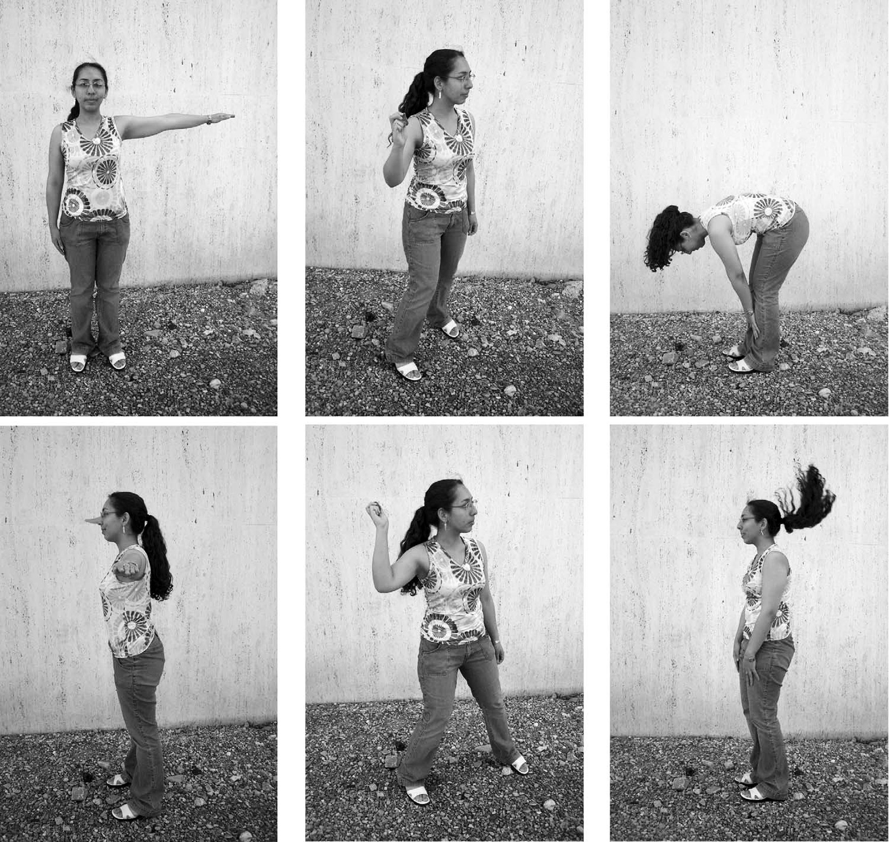

**Figure 16.1.** Action layout. Left: Staging action properly is crucial for bringing attention to currently important motion. The act of raising a hand would be prominent on the top but harder to notice on the bottom. A change in nose length, on the contrary, might be completely invisible in the first case. Note that this might be intentionally hidden, for example, to be suddenly revealed later. Neither arrangement is particularly good if both motions should be attended to. Middle: The amount of anticipation can tell much about the following action. The action which is about to follow (throwing a ball) is very short, but it is clear what is about to happen. The more wound up the character is, the faster the following action is perceived to be. Right: The follow-through phase is especially important for secondary appendages (hair) whose motion follows the leading part (head). The motion of the head is very simple, but leads to nontrivial follow-through behavior of the hair itself. It is impossible to create a natural animation without a follow-through phase and overlapping action in this case. *Figure courtesy Peter Shirley and Christina Villarruel.*

the least interesting. For example, kicking a football might involve extensive preparation on the part of the kicker and long “visual tracking” of the departing ball with ample opportunities to show the stress of the moment, emotional state of the kicker, and even the reaction to the expected result of the action. The action itself (motion of the leg to kick the ball) is rather plain and takes just a fraction of a second in this case.

The goal of anticipation is to prepare the viewer for what is about to hap- pen. This becomes especially important if the action itself is very fast, greatly

important, or extremely difficult. Creating a more extensive anticipation for such actions serves to underscore these properties and, in case of fast events, makes sure the action will not be missed (see Figure 16.1 (bottom center)).

In real life, the main action often causes one or more other *overlapping ac- tions*. Different appendages or loose parts of the object typically drag behind the main leading section and keep moving for a while in the follow-through part of the main action as shown in Figure 16.1 (bottom right). Moreover, the next ac- tion often starts before the previous one is completely over. A player might start running while he is still tracking the ball he just kicked. Ignoring such natural flow is generally perceived as if there are pauses between actions and can result in robot-like mechanical motion. While overlapping is necessary to keep the motion natural, *secondary action* is often added by the animator to make motion more interesting and achieve realistic complexity of the animation. It is important not to allow secondary action to dominate the main action.

* + 1. Animation Techniques

Several specific techniques can be used to make motion look more natural. The most important one is probably *squash and stretch* which suggests to change the shape of a moving object in a particular way as it moves. One would generally stretch an object in the direction of motion and squash it when a force is ap- plied to it, as demonstrated in Figure 16.2 for a classic animation of a bouncing ball. It is important to preserve the total volume as this happens to avoid the il- lusion of growing or shrinking of the object. The greater the speed of motion (or the force), the more stretching (or squashing) is applied. Such deformations are used for several reasons. For very fast motion, an object can move between two sequential frames so quickly that there is no overlap between the object at the time of the current frame and at the time of the previous frame which can lead to strobing (a variant of aliasing). Having the object elongated in the direction of motion can ensure better overlap and helps the eye to fight this unpleasant effect. Stretching/squashing can also be used to show flexibility of the object with more deformation applied for more pliable materials. If the object is intended to appear as rigid, its shape is purposefully left the same when it moves.

Natural motion rarely happens along straight lines, so this should generally be avoided in animation and *arcs* should be used instead. Similarly, no real-world motion can instantly change its speed—this would require an infinite amount of force to be applied to an object. It is desirable to avoid such situations in anima- tion as well. In particular, the motion should start and end gradually (*slow in and out*). While hand-drawn animation is sometimes done via *straight-ahead action*

**Figure 16.2.** Classic ex- ample of applying the squash and stretch principle. Note that the volume of the bounc- ing ball should remain roughly the same throughout the ani- mation.

Key frames (created ﬁrst)

Time

Straight ahead order of frame creation

**Figure 16.3.** Keyfram- ing (top) encourages detailed action planning while straight- ahead action (bottom) leads to a more spontaneous result.

with an animator starting at the first frame and drawing one frame after another in sequence until the end, *pose-to-pose action*, also known as *keyframing*, is much more suitable for computer animation. In this technique, animation is carefully planned through a series of relatively sparsely spaced key frames with the rest of the animation (in-between frames) filled in only after the keys are set (Fig- ure 16.3). This allows more precise timing and allows the computer to take over the most tedious part of the process—the creation of the in-between frames— using algorithms presented in the next section.

Almost any of the techniques outlined above can be used with some reason- able amount of *exaggeration* to achieve greater artistic effect or underscore some specific property of an action or a character. The ultimate goal is to achieve some- thing the audience will want to see, something which is *appealing*. Extreme com- plexity or too much symmetry in a character or action tends to be less appealing. To create good results, a traditional animator needs *solid drawing skills*. Analo- gously, a computer animator should certainly understand computer graphics and have a solid knowledge of the tools he uses.



* + 1. Animator Control vs. Automatic Methods

In traditional animation, the animator has complete control over all aspects of the production process and nothing prevents the final product to be as it was planned in every detail. The price paid for this flexibility is that every frame is created by hand, leading to an extremely time- and labor-consuming enterprise. In computer animation, there is a clear tradeoff between, on the one hand, giving an animator more direct control over the result, but asking him to contribute more work and, on the other hand, relying on more automatic techniques which might require setting just a few input parameters but offer little or no control over some of the properties of the result. A good algorithm should provide sufficient flexibility while asking an animator only the information which is intuitive, easy to provide, and which he himself feels is necessary for achieving the desired effect. While perfect compliance with this requirement is unlikely in practice since it would probably take something close to a mind-reading machine, we do encourage the reader to evaluate any computer-animation technique from the point of view of providing such *balance*.

# Keyframing

The term keyframing can be misleading when applied to 3D computer animation since no actual completed frames (i.e., images) are typically involved. At any

|  |  |  |  |  |  |  |  |  |  |  |  |  |  |  |  |
| --- | --- | --- | --- | --- | --- | --- | --- | --- | --- | --- | --- | --- | --- | --- | --- |
|  |  |  |  |  |  |  |  |  |  |  |  |  |  |  |  |
|  |  |  |  |  |  |  |  |  |  |  |  |  |  |  |  |
|  |  |  |  |  |  |  |  |  |  |  |  |  |  |  |  |
|  |  |  |  |  |  |  |  |  |  |  |  |  |  |  |  |
|  |  |  |  |  |  |  |  |  |  |  |  |  |  |  |  |
|  |  |  |  |  |  |  |  |  |  |  |  |  |  |  |  |
|  |  |  |  |  |  |  |  |  |  |  |  |  |  |  |  |
|  |  |  |  |  |  |  |  |  |  |  |  |  |  |  |  |

**Figure 16.4.** Different patterns of setting keys (black circles above) can be used simultaneously for the same scene. It is assumed that there are more frames before, as well as after, this portion.



Frames

Time

Scene parameters

given moment, a 3D scene being animated is specified by a set of numbers: the positions of centers of all objects, their RGB colors, the amount of scaling applied to each object in each axis, modeling transformations between different parts of a complex object, camera position and orientation, light sources intensity, etc. To animate a scene, some subset of these values have to change with time. One can, of course, directly set these values at every frame, but this will not be particularly efficient. Short of that, some number of important moments in time (key frames *tk*) can be chosen along the timeline of animation for each of the parameters and values of this parameter (key values *fk*) are set only for these selected frames. We will call a combination (*tk, fk*) of key frame and key value simply a key. Key frames do not have to be the same for different parameters, but it is often

logical to set keys at least for some of them simultaneously. For example, key frames chosen for *x*-, *y*- and *z*-coordinates of a specific object might be set at exactly the same frames forming a single position vector key (*tk,* **pk**). These key frames, however, might be completely different from those chosen for the object’s orientation or color. The closer key frames are to each other, the more control the

animator has over the result; however the cost of doing more work of setting the keys has to be assessed. It is, therefore, typical to have large spacing between keys in parts of the animation which are relatively simple, concentrating them in intervals where complex action occurs, as shown in Figure 16.4.

Once the animator sets the key (*tk, fk*), the system has to compute values of *f* for all other frames. Although we are ultimately interested only in a discrete set of values, it is convenient to treat this as a classical interpolation problem which fits a continuous *animation curve f* (*t*) through a provided set of data points (Fig- ure 16.5). Extensive discussion of curve-fitting algorithms can be found in Chap-



*f*

Keys

*t*

Frame positions

*df*/*dt*

*t*

**Figure 16.5.** A continu- ous curve *f(t)* is fit through the keys provided by the anima- tor even though only values at frame positions are of interest. The derivative of this function gives the speed of parameter change and is at first deter- mined automatically by the fit- ting procedure.

ter 15, and we will not repeat it here. Since the animator initially provides only the keys and not the derivative (tangent), methods which compute all necessary infor- mation directly from keys are preferable for animation. The speed of parameter change along the curve is given by the derivative of the curve with respect to time

*df /dt*. Therefore, to avoid sudden jumps in velocity, *C*1 continuity is typically necessary. A higher degree of continuity is typically not required from animation

curves, since the second derivative, which corresponds to acceleration or applied force, can experience very sudden changes in real-world situations (ball hitting a solid wall), and higher derivatives do not directly correspond to any parameters of physical motion. These consideration make Catmull-Rom splines one of the best choices for initial animation curve creation.

Most animation systems give the animator the ability to perform interactive fine editing of this initial curve, including inserting more keys, adjusting existing keys, or modifying automatically computed tangents. Another useful technique which can help to tweak the shape of the curve is called TCB control (TCB stands for tension, continuity, and bias). The idea is to introduce three new parameters which can be used to modify the shape of the curve near a key through coordinated adjustment of incoming and outgoing tangents at this point. For keys uniformly spaced in time with distance Δ*t* between them, the standard Catmull-Rom ex-

pression for incoming *T in* and outgoing *T out* tangents at an internal key (*tk, fk*)

*i i*

can be rewritten as

*T in* = *T out* = 1 (*f*

*k*

*k*

2Δ*t*

1

*− f* )+ (*f − f* )*.*

*k*+1

*k*

2Δ*t*

*k*

*k−*1

Modified tangents of a TCB spline are

*T in* = (1 *− t*)(1 *− c*)(1 + *b*)(*f*

*k*

2Δ*t*

*k*+1

*− f* )+ (1 *− t*)(1 + *c*)(1 *− b*)(*f − f* )*,*

*T out* = (1 *− t*)(1 + *c*)(1 + *b*)(*f*

*k*

2Δ*t*

*k*

*k−*1

*k*

2Δ*t*

*− f* )+ (1 *− t*)(1 *− c*)(1 *− b*)(*f − f* )*.*

The tension parameter *t* controls the sharpness of the curve near the key by scaling both incoming and outgoing tangents. Larger tangents (lower tension) lead to a flatter curve shape near the key. Bias *b* allows the animator to selectively increase the weight of a key’s neighbors locally pulling the curve closer to a straight line

*k*+1

*k*

2Δ*t*

*k*

*k−*1

connecting the key with its left (*b* near 1, “overshooting” the action) or right (*b* near *−*1, “undershooting” the action) neighbors. A nonzero value of continuity *c* makes incoming and outgoing tangents different allowing the animator to create

kinks in the curve at the key value. Practically useful values of TCB parameters are typically confined to the interval [*−*1; 1] with defaults *t* = *c* = *b* = 0 corre- sponding to the original Catmull-Rom spline. Examples of possible curve shape

adjustments are shown in Figure 16.6.

Low tension, *t* < 0

Original spline, *t* = *c* = *b* = 0

High tension, *t* > 0

Low continuity, *c* < 0

Original spline, *t* = *c* = *b* = 0

High continuity, *c* > 0

Low bias, *b* < 0

Original spline, *t* = *c* = *b* = 0

High bias, *b* > 0

**Figure 16.6.** Editing the default interpolating spline (middle column) using TCB controls. Note that all keys remain at the same positions.

* + 1. Motion Controls

So far, we have described how to control the shape of the animation curve through key positioning and fine tweaking of tangent values at the keys. This, however, is generally not sufficient when one would like to have control both over where the object is moving, i.e., its path, and how fast it moves along this path. Given a set of positions in space as keys, automatic curve-fitting techniques can fita curve through them, but resulting motion is only constrained by forcing the object to arrive at a specified key position **pk** at the corresponding key frame *tk*, and noth- ing is directly said about the speed of motion between the keys. This can create problems. For example, if an object moves along the *x*-axis with velocity 11 me- ters per second for 1 second and then with 1 meter per second for 9 seconds, it

will arrive at position *x* = 20 after 10 seconds thus satisfying animator’s keys (0,0) and (10, 20). It is rather unlikely that this jerky motion was actually de- sired, and uniform motion with speed 2 meters/second is probably closer to what

the animator wanted when setting these keys. Although typically not displaying



t=3

t=0

t=6

t=9

t=12

**Figure 16.7.** All three mo- tions are along the same 2D path and satisfy the set of keys at the tips of the black trian- gles. The tips of the white

triangles show object position at Δ*t* = 1 intervals. Uni- form speed of motion between the keys (top) might be closer to what the animator wanted, but automatic fitting proce-

dures could result in either of the other two motions.

such extreme behavior, polynomial curves resulting from standard fitting proce- dures do exhibit nonuniform speed of motion between keys as demonstrated in Figure 16.7. While this can be tolerable (within limits) for some parameters for which the human visual system is not very good at determining nonuniformities in the rate of change (such as color or even rate of rotation), we have to do bet- ter for position **p** of the object where velocity directly corresponds to everyday experience.

We will first distinguish curve parameterization used during the fitting proce- dure from that used for animation. When a curve is fit through position keys, we will write the result as a function **p**(*u*) of some parameter *u*. This will describe the geometry of the curve in space. The arc length *s* is the physical length of the curve. A natural way for the animator to control the motion along the now- existing curve is to specify an extra function *s*(*t*) which corresponds to how far along the curve the object should be at any given time. To get an actual position in space, we need one more auxiliary function *u*(*s*) which computes a parame- ter value *u* for given arc length *s*. The complete process of computing an object position for a given time *t* is then given by composing these functions (see Fig- ure 16.8):

**p**(*t*) = **p**(*u*(*s*(*t*)))*.*

Several standard functions can be used as the distance-time function *s*(*t*). One of the simplest is the linear function corresponding to constant velocity: *s*(*t*) = *vt* with *v* = const. Another common example is the motion with con- stant acceleration *a* (and initial speed *v*0) which is described by the parabolic *s*(*t*) = *v*0*t* + *at*2*/*2. Since velocity is changing gradually here, this function can help to model desirable ease-in and ease-out behavior. More generally, the slope of *s*(*t*) gives the velocity of motion with negative slope corresponding to the motion backwards along the curve. To achieve most flexibility, the ability to



*s*

*u*

*u*(*s*)

**P**(*u*(*s*(*t*)))

*s*(*t*)

*u*(*s*(*t*))

*t*

*s*

**P**(*u*)

*s*(*t*)

**Figure 16.8.** To get position in space at a given time *t*, one first utilizes user-specified motion control to obtain the distance along the curve *s*(*t*) and then computes the corresponding curve parameter value *u*(*s*(*t*)). Previously fitted curve **P**(*u*) can now be used to find the position **P**(*u*(*s*(*t*))).

interactively edit *s*(*t*) is typically provided to the animator by the animation sys- tem. The distance-time function is not the only way to control motion. In some cases it might be more convenient for the user to specify a velocity-time function *v*(*t*) or even an acceleration-time function *a*(*t*). Since these are correspondingly first and second derivatives of *s*(*t*), to use these type of controls, the system first

recovers the distance-time function by integrating the user input (twice in the case of *a*(*t*)).

The relationship between the curve parameter *u* and arc length *s* is established

automatically by the system. In practice, the system first determines arc length

dependance on parameter *u* (i.e., the inverse function *s*(*u*)). Using this function, for any given *S* it is possible to solve the equation *s*(*u*) *− S* = 0 with unknown *u* obtaining *u*(*S*). For most curves, the function *s*(*u*) cannot be expressed in closed

analytic form and numerical integration is necessary (see Chapter 14). Standard numerical root-finding procedures (such as the Newton-Raphson method, for ex-

ample) can then be directly used to solve the equation *s*(*u*) *− S* = 0 for *u*.

An alternative technique is to approximate the curve itself as a set of linear

segments between points **p***i* computed at some set of sufficiently densely spaced parameter values *ui*. One then creates a table of approximate arc lengths

Σ

*i*

|  |  |
| --- | --- |
| 0.0 | 0.0 |
| 0.2 | 2.5 |
| 0.4 | 4.0 |
| 0.6 | 5.0 |
| 0.8 | 7.0 |
| 1.0 | 8.5 |

**Figure 16.9.** To cre- ate a tabular version of *s*(*u*), the curve can be approximated by a number of line segments connecting points on the curve positioned at equal parame-

*u* = 0.2 *u* = 0.4

*u* = 0.6 *u* = 1.0

*u* = 0

*u s*(*u*)

*u* = 0.8

*s*(*ui*) *≈*

*j*=1

*||***pj** *−* **pj***−***1***||* = *s*(*ui−*1)+ *||***pi** *−* **pi***−***1***||.*

ter increments. The table is searched to find the *u*-interval for a given *S*. For the curve above, for example, the value

Since *s*(*u*) is a non-decreasing function of *u*, one can then find the interval con-

taining the value *S* by simple searching through the table (see Figure 16.9). Linear interpolation of the interval’s *u* end values is then performed to finally find u(S). If greater precision is necessary, a few steps of the Newton-Raphson algorithm with this value as the starting point can be applied.

* + 1. Interpolating Rotation

The techniques presented above can be used to interpolate the keys set for most of the parameters describing the scene. Three-dimensional rotation is one important motion for which more specialized interpolation methods and representations are common. The reason for this is that applying standard techniques to 3D rotations often leads to serious practical problems. Rotation (a change in orientation of an object) is the only motion other than translation which leaves the shape of the object intact. It therefore plays a special role in animating rigid objects.

There are several ways to specify the orientation of an object. First, trans- formation matrices as described in Chapter 6 can be used. Unfortunately, naive

of *u* corresponding to the po- sition of *S* = 6.5 lies between *u*

= 0.6 and *u* = 0.8.

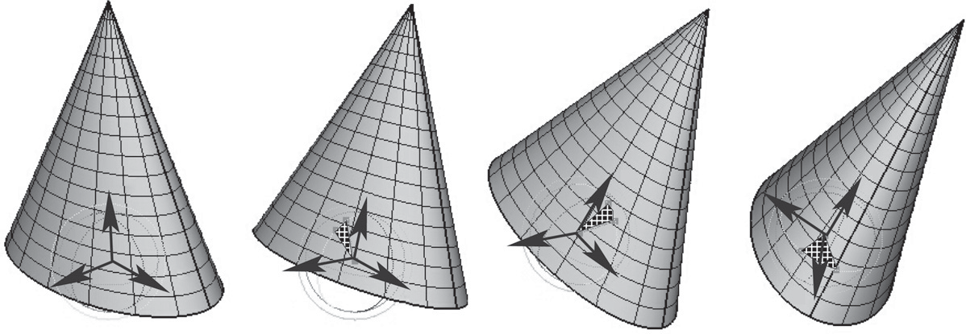

Rotate (X)

Rotate (Z)

Rotate (Y)

Y

Y

Y

Z

Y

Z

Z

X

Z

X

X

X

**Figure 16.10.** Three Euler angles can be used to specify arbitrary object orientation through a sequence of three rotations around coordinate axes embedded into the object (axis Y always points to the tip of the cone). Note that each rotation is given in a new coordinate system. Fixed angle representation is very similar, but the coordinate axes it uses are fixed in space and do not rotate with the object.

(element-by-element) interpolation of rotation matrices does not produce a correct result. For example, the matrix “halfway” between 2D clock- and counterclock- wise 90 degree rotation is the null matrix:



Rotate(Z)

Rotate(X)

Rotate(Y) Original conﬁguration

Rotate(Z)

Rotate(X)

Rotate(Y) Gimbal lock conﬁguration

1 Σ 0 1Σ + 1 Σ0 *−*1Σ = Σ0 0Σ *.*

2

*−*1 0

2

1 0

0 0



**Figure 16.11.** In this exam- ple, gimbal lock occurs when a 90 degree turn around axis Z is made. Both X and Y rotations are now performed around the same axis leading to the loss of one degree of freedom.

The correct result is, of course, the unit matrix corresponding to no rotation. Sec- ond, one can specify arbitrary orientation as a sequence of exactly three rotations around coordinate axes chosen in some specific order. These axes can be fixed in space (*fixed-angle* representation) or embedded into the object therefore changing after each rotation (*Euler-angle* representation as shown in Figure 16.10). These three angles of rotation can be animated directly through standard keyframing, but a subtle problem known as gimbal lock arises. Gimbal lock occurs if dur- ing rotation one of the three rotation axes is by accident aligned with another, thereby reducing by one the number of available degrees of freedom as shown in Figure 16.11 for a physical device. This effect is more common than one might think—a single 90 degree turn to the right (or left) can potentially put an object into a gimbal lock. Finally, any orientation can be specified by choosing an appro- priate axis in space and angle of rotation around this axis. While animating in this representation is relatively straightforward, combining two rotations, i.e., finding the axis and angle corresponding to a sequence of two rotations both represented by axis and angle, is nontrivial. A special mathematical apparatus, *quaternions* has been developed to make this representation suitable both for combining sev- eral rotations into a single one and for animation.

Given a 3D vector **v** = (*x, y, z*) and a scalar *s*, a quaternion *q* is formed by

combining the two into a four-component object: *q* = [*s x y z*] = [*s*; **v**]. Several

new operations are then defined for quaternions. Quaternion addition simply sums scalar and vector parts separately:

*q*1 + *q*2 *≡* [*s*1 + *s*2; **v1** + **v2**]*.*

Multiplication by a scalar *a* gives a new quaternion

*aq ≡* [*as*; *a***v**]*.*

More complex quaternion multiplication is defined as

*q*1 *· q*2 *≡* [*s*1*s*2 *−* **v1v2**; *s*1**v2** + *s*2**v1** + **v1** *×* **v2**]*,*

where *×* denotes a vector cross product. It is easy to see that, similar to matrices, quaternion multiplication is associative, but not commutative. We will be inter-

ested mostly in normalized quaternions—those for which the quaternion norm



*q*1

*q*2

*√*

*|q|* = *s*2 + **v**2 is equal to one. One final definition we need is that of an inverse quaternion:

*q−*1 = (1*/|q|*)[*s*; *−***v**]*.*

To represent a rotation by angle *φ* around an axis passing through the origin whose direction is given by the normalized vector **n**, a normalized quaternion

*q* = [cos(*φ/*2); sin(*φ/*2)**n**]

is formed. To rotate point **p**, one turns it into the quaternion *qp* = [0; **p**] and computes the quaternion product

*qpj* = *q · qp · q−*1

which is guaranteed to have a zero scalar part and the rotated point as its vector part. Composite rotation is given simply by the product of quaternions represent- ing each of the separate rotation steps. To animate with quaternions, one can treat them as points in a four-dimensional space and set keys directly in this space. To keep quaternions normalized, one should, strictly speaking, restrict interpolation procedures to a unit sphere (a 3D object) in this 4D space. However, a spherical version of even linear interpolation (often called *slerp*) already results in rather unpleasant math. Simple 4D linear interpolation followed by projection onto the unit sphere shown in Figure 16.12 is much simpler and often sufficient in practice. Smoother results can be obtained via repeated application of a linear interpolation procedure using the de Casteljau algorithm.

**Figure 16.12.** Interpolating quaternions should be done on the surface of a 3D unit sphere embedded in 4D space. How- ever, much simpler interpola- tion along a 4D straight line (open circles) followed by re- projection of the results onto the sphere (black circles) is of- ten sufficient.

# Deformations

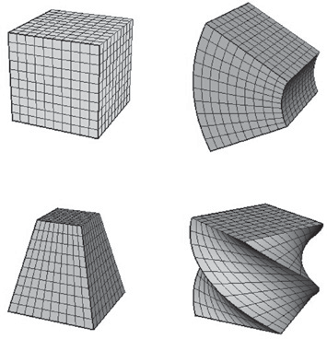

Original shape Bend

Taper

Twist

**Figure 16.13.** Popu- lar examples of global defor- mations. Bending and twist angles, as well as the de- gree of taper, can all be an- imated to achieve dynamic shape change.

Although techniques for object deformation might be more properly treated as modeling tools, they are traditionally discussed together with animation methods. Probably the simplest example of an operation which changes object shape is a nonuniform scaling. More generally, some function can be applied to local co- ordinates of all points specifying the object (i.e., vertices of a triangular mesh or control polygon of a spline surface), repositioning these points and creating a new shape: **p***j* = *f* (**p***, γ*) where *γ* is a vector of parameters used by the deforma-

tion function. Choosing different *f* (and combining them by applying one after

another) can help to create very interesting deformations. Examples of useful simple functions include bend, twist, and taper which are shown in Figure 16.13. Animating shape change is very easy in this case by keyframing the parameters of the deformation function. Disadvantages of this technique include difficulty of choosing the mathematical function for some nonstandard deformations and the fact that the resulting deformation is *global* in the sense that the complete object, and not just some part of it, is reshaped.

To deform an object locally while providing more direct control over the re- sult, one can choose a single vertex, move it to a new location and adjust vertices within some neighborhood to follow the seed vertex. The area affected by the de- formation and the specific amount of displacement in different parts of the object are controlled by an attenuation function which decreases with distance (typically computed over the object’s surface) to the seed vertex. Seed vertex motion can be keyframed to produce animated shape change.

A more general deformation technique is called free-form deformation (FFD) (Sederberg & Parry, 1986). A local (in most cases rectilinear) coordinate grid is first established to encapsulate the part of the object to be deformed, and co- ordinates (*s, t, u*) of all relevant points are computed with respect to this grid.

The user then freely reshapes the grid of lattice points **Pijk** into a new distorted

lattice **P***j***ijk** (Figure 16.14). The object is reconstructed using coordinates com- puted in the original undistorted grid in the trivariate analog of Be´zier interpolants (see Chapter 15) with distorted lattice points **P***j***ijk** serving as control points in this expression:

*M*

*N*

*P* (*s, u, t*) =

*L*

Σ*i*=0

. *i* Σ

*L*

(1 *− s*)*L−isi*

Σ*j*=0

. *j* Σ

*M*

(1 *− t*)*M−jtj*

*k*Σ=0

. *k* Σ

*N*

(1 *− u*)*N−kuk***P***j***ijk***,*

where *L, M, N* are maximum indices of lattice points in each dimension. In ef- fect, the lattice serves as a low-resolution version of the object for the purpose of deformation, allowing for a smooth shape change of an arbitrarily complex ob-

ject through a relatively small number of intuitive adjustments. FFD lattices can themselves be treated as regular objects by the system and can be transformed, an- imated, and even further deformed if necessary, leading to corresponding changes in the object to which the lattice is attached. For example, moving a *deforma- tion tool* consisting of the original lattice and distorted lattice representing a bulge across an object results in a bulge moving across the object.

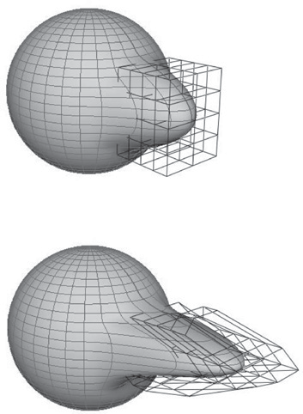

# Character Animation

Animation of articulated figures is most often performed through a combination of keyframing and specialized deformation techniques. The character model in- tended for animation typically consists of at least two main layers as shown in Figure 16.15. The motion of a highly detailed surface representing the outer shell or *skin* of the character is what the viewer will eventually see in the final prod- uct. The *skeleton* underneath it is a hierarchical structure (a tree) of joints which provides a kinematic model of the figure and is used exclusively for animation. In some cases, additional intermediate layer(s) roughly corresponding to muscles are inserted between the skeleton and the skin.

**Figure 16.14.** Adjusting the FFD lattice results in the de- formation of the object.

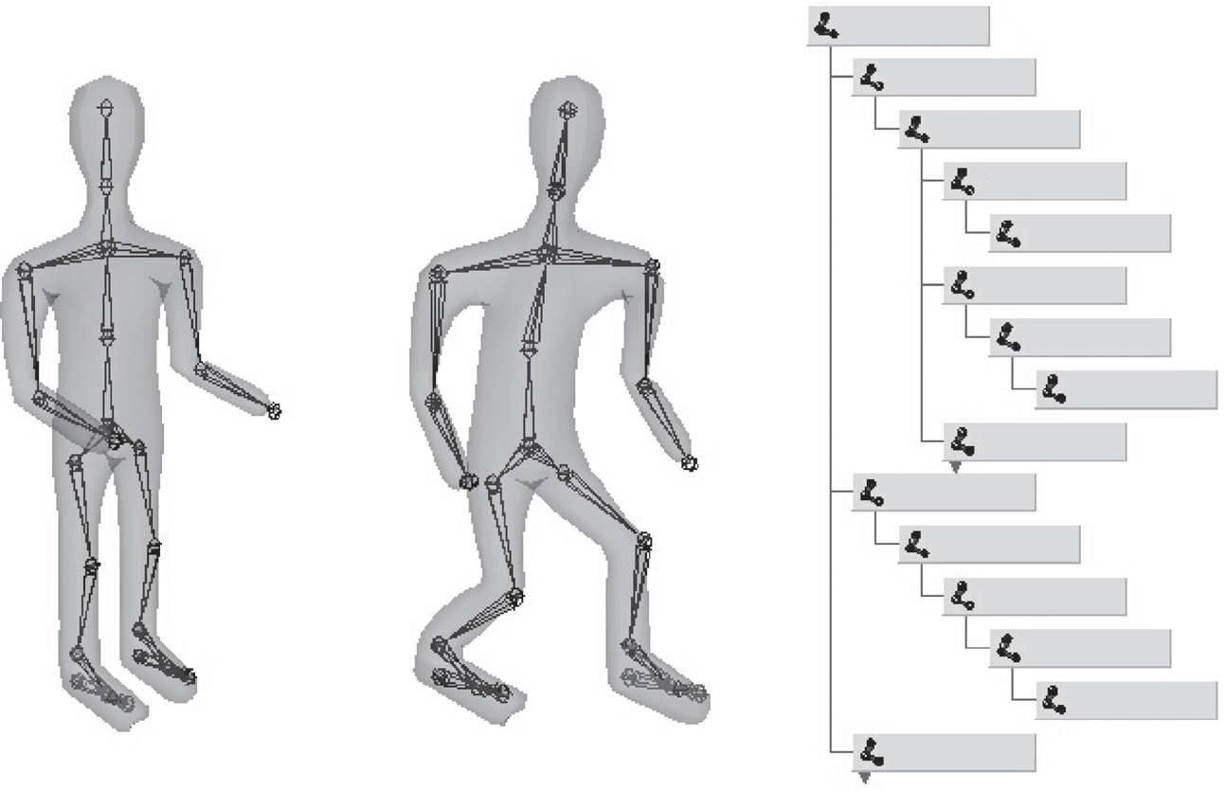

Skin

Skeleton

pelvis

spine

collar

neck

head rshoulder

elbow

wrist lshoulder

rhip

knee

ankle

ball

toe

lhip

**Figure 16.15.** (Left) A hierarchy of joints, a skeleton, serves as a kinematic abstraction of the character; (middle) repositioning the skeleton deforms a separate skin object attached to it; (right) a tree data structure is used to represent the skeleton. For compactness, the internal structure of several nodes is hidden (they are identical to a corresponding sibling).

Each of the skeleton’s joints acts as a parent for the hierarchy below it. The root represents the whole character and is positioned directly in the world coor- dinate system. If a local transformation matrix which relates a joint to its parent in the hierarchy is available, one can obtain a transformation which relates local space of any joint to the world system (i.e., the system of the root) by simply con- catenating transformations along the path from the root to the joint. To evaluate the whole skeleton (i.e., find position and orientation of all joints), a depth-first traversal of the complete tree of joints is performed. A transformation stack is a natural data structure to help with this task. While traversing down the tree, the current composite matrix is pushed on the stack and a new one is created by mul- tiplying the current matrix with the one stored at the joint. When backtracking to the parent, this extra transformation should be undone before another branch is visited; this is easily done by simply popping the stack. Although this general and simple technique for evaluating hierarchies is used throughout computer graphics, in animation (and robotics) it is given a special name—*forward kinematics* (FK). While general representations for all transformations can be used, it is common to use specialized sets of parameters, such as link lengths or joint angles, to specify skeletons. To animate with forward kinematics, rotational parameters of all joints are manipulated directly. The technique also allows the animator to change the distance between joints (link lengths), but one should be aware that this corre- sponds to limb stretching and can often look rather unnatural.

Forward kinematics requires the user to set parameters for all joints involved in the motion (Figure 16.16 (top)). Most of these joints, however, belong to in-

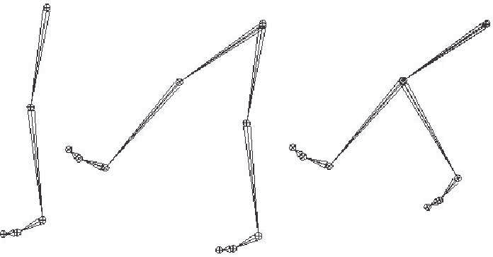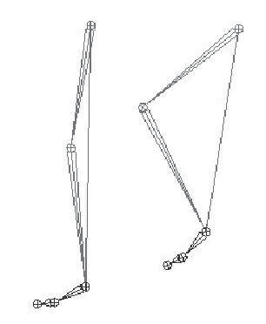

Eﬀector motion

Hip and knee joint angles computed automatically

IK solver connection

Original

After knee rotation

After hip rotation

**Figure 16.16.** Forward kinematics (top) requires the animator to put all joints into correct position. In inverse kinematic (bottom), parameters of some internal joints are computed based on desired end effector motion.

ternal nodes of the hierarchy, and their motion is typically not something the animator wants to worry about. In most situations, the animator just wants them to move naturally “on their own,” and one is much more interested in specify- ing the behavior of the endpoint of a joint chain, which typically corresponds to something performing a specific action, such as an ankle or a tip of a finger. The animator would rather have parameters of all internal joints be determined from the motion of the end effector automatically by the system. *Inverse kinematics* (IK) allows us to do just that (see Figure 16.16 (bottom)).

Let **x** be the position of the end effector and *α* be the vector of parameters needed to specify all internal joints along the chain from the root to the final joint. Sometimes the orientation of the final joint is also directly set by the animator, in which case we assume that the corresponding variables are included in the vector

**x**. For simplicity, however, we will write all specific expressions for the vector:

**x** = (*x*1*, x*2*, x*3)*T .*

Since each of the variables in **x** is a function of *α*, it can be written as a vector equation **x** = **F**(*α*). If we change the internal joint parameters by a small amount *δα*, a resulting change *δ***x** in the position of the end effector can be approximately written as

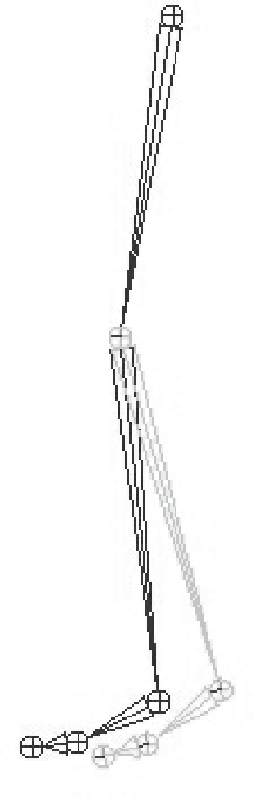

Δ

knee

*x*

Δ*x*

*δ***x** =

*∂***F**

*δα,* (16.1)

*∂α*

where *∂***F** is the matrix of partial derivatives called the Jacobian:

*∂α*

⎡ *∂f*1

*∂***F**

*∂f*1

*... ∂f*1 ⎤

*∂α*1

= ⎢⎣

*∂f*2

*∂α*1

*∂α*

*∂f*3

*∂α*1

*∂α*2

*∂f*2

*∂α*2

*∂f*3

*∂α*2

*∂αn*

*∂f*2

*...* ⎥⎦ *.*

*∂αn*

*... ∂f*3

*∂α*

*n*

At each moment in time, we know the desired position of the end effector (set by the animator) and, of course, the effector’s current position. Subtracting the two, we will get the desired adjustment *δ***x**. Elements of the Jacobian matrix are related to changes in a coordinate of the end effector when a particular internal parameter is changed while others remain fixed (see Figure 16.17). These elements can be computed for any given skeleton configuration using geometric relationships. The only remaining unknowns in the system of equations (16.1) are the changes in internal parameters *α*. Once we solve for them, we update *α* = *α*+*δα* which gives

all the necessary information for the FK procedure to reposition the skeleton.

Unfortunately, the system (16.1) cannot usually be solved analytically and, moreover, it is in most cases underconstrained, i.e., the number of unknown inter- nal joint parameters *α* exceeds the number of variables in vector **x**. This means that different motions of the skeleton can result in the same motion of the end

**Figure 16.17.** Partial derivative *∂x/∂α*knee is given by the limit of Δ*x/*Δ*α*knee. Effector dis- placement is computed while all joints, except the knee, are kept fixed.

effector. Some examples are shown on Figure 16.18. Many ways of obtain- ing specific solution for such systems are available, including those taking into account natural *constraints* needed for some

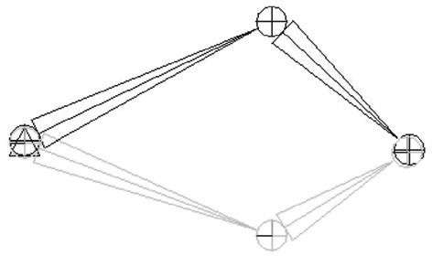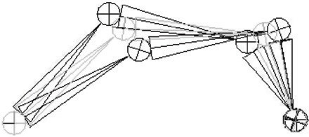

IK root

position

Eﬀector

real-life joints (bending a knee only in one direction, for example). One should also remember that the computed Jacobian ma- trix is valid only for one specific configura- tion, and it has to be updated as the skele- ton moves. The complete IK framework is presented in Figure 16.19. Of course, the root joint for IK does not have to be the root of the whole hierarchy, and multiple IK solvers can be applied to independent parts of the skeleton. For example, one can use

separate solvers for right and left feet and yet another one to help animate grasping with the right hand, each with its own root.

**Figure 16.18.** Multiple configurations of

internal joints can result in the same effector position. (Top) disjoint “flipped” solutions; (bottom) a continuum of solutions.

A combination of FK and IK approaches is typically used to animate the skele- ton. Many common motions (walking or running cycles, grasping, reaching, etc.) exhibit well-known patterns of mutual joint motion making it possible to quickly



Old skeleton configuration

New values for internal joint parameters Apply forward kinematic to reposition skeleton

New skeleton configuration

No

Replace old skeleton configuration with the new one

Yes, done

Effector at desired position ?

Solve equation 1.1

Compute the Jacobian and desired effector motion

Update constraints

**Figure 16.19.** A diagram of the inverse kinematic algorithm.

create naturally looking motion or even use a library of such “clips.” The ani- mator then adjusts this generic result according to the physical parameters of the character and also to give it more individuality.

When a skeleton changes its position, it acts as a special type of deformer

applied to the skin of the character. The motion is transferred to this surface by assigning each skin vertex one (*rigid skinning*) or more (*smooth skinning*) joints as drivers (see Figure 16.20). In the first case, a skin vertex is simply frozen into the local space of the corresponding joint, which can be the one nearest in space or one chosen directly by the user. The vertex then repeats whatever mo- tion this joint experiences, and its position in world coordinates is determined by standard FK procedure. Although it is simple, rigid skinning makes it difficult to obtain sufficiently smooth skin deformation in areas near the joints or also for more subtle effects resembling breathing or muscle action. Additional specialized deformers called *flexors* can be used for this purpose. In smooth skinning, several joints can influence a skin vertex according to some weight assigned by the ani- mator, providing more detailed control over the results. Displacement vectors, **di**, suggested by different joints affecting a given skin vertex (each again computed with standard FK) are averaged according to their weights *wi* to compute the fi-

Σ Σ

nal displacement of the vertex **d** = *wi***di**. Normalized weights ( *wi* = 1) are the most common but not fundamentally necessary. Setting smooth skinning weights to achieve the desired effect is not easy and requires significant skill from

the animator.

* + 1. Facial Animation

Skeletons are well suited for creating most motions of a character’s body, but they are not very convenient for realistic facial animation. The reason is that the skin of a human face is moved by muscles directly attached to it, contrary to other parts of the body where the primary objective of the muscles is to move the bones of the skeleton and any skin deformation is a secondary outcome. The result of this facial anatomical arrangement is a very rich set of dynamic facial expressions humans use as one of the main instruments of communication. We are all very well trained to recognize such facial variations and can easily notice any unnatural appearance. This not only puts special demands on the animator but also requires a high-resolution geometric model of the face and, if photorealism is desired, accurate skin reflection properties and textures.

While it is possible to set key poses of the face vertex-by-vertex and inter- polate between them or directly simulate the behavior of the underlying mus- cle structure using physics-based techniques (see Section 16.5), more specialized

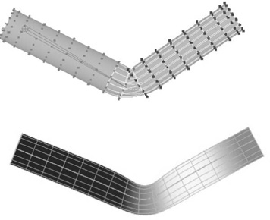

**Figure 16.20.** Top: Rigid skinning assigns skin vertices to a specific joint. Those belonging to the elbow joint are shown in black; Bot- tom: Soft skinning can blend the influence of several joints. Weights for the elbow joint are shown (lighter = greater weight). Note smoother skin deformation of the inner part of the skin near the joint.

high-level approaches also exist. The static shape of a specific face can be charac- terized by a relatively small set of so-called *conformational parameters* (overall scale, distance from the eye to the forehead, length of the nose, width of the jaws, etc.) which are used to morph a generic face model into one with individual features. An additional set of *expressive parameters* can be used to describe the dynamic shape of the face for animation. Examples include rigid rotation of the head, how wide the eyes are open, movement of some feature point from its static position, etc. These are chosen so that most of the interesting expressions can be obtained through some combination of parameter adjustments, therefore, allow- ing a face to be animated via standard keyframing. To achieve a higher level of control, one can use expressive parameters to create a set of expressions corre- sponding to common emotions (neutral, sadness, happiness, anger, surprise, etc.) and then blend these key poses to obtain a “slightly sad” or “angrily surprised” face. Similar techniques can be used to perform lip-synch animation, but key poses in this case correspond to different phonemes. Instead of using a sequence of static expressions to describe a dynamic one, the Facial Action Coding Sys- tem (FACS) (Eckman & Friesen, 1978) decomposes dynamic facial expressions directly into a sum of elementary motions called action units (AUs). The set of AUs is based on extensive psychological research and includes such movements as raising the inner brow, wrinkling the nose, stretching lips, etc. Combining AUs can be used to synthesize a necessary expression.

* + 1. Motion Capture

Even with the help of the techniques described above, creating realistic-looking character animation from scratch remains a daunting task. It is therefore only natural that much attention is directed toward techniques which record an actor’s motion in the real world and then apply it to computer-generated characters. Two main classes of such *motion capture* (MC) techniques exist: electromagnetic and optical.

In electromagnetic motion capture, an electromagnetic sensor directly mea- sures its position (and possibly orientation) in 3D, often providing the captured results in real time. Disadvantages of this technique include significant equip- ment cost, possible interference from nearby metal objects, and noticeable size of sensors and batteries which can be an obstacle in performing high-amplitude motions. In optical MC, small colored markers are used instead of active sensors making it a much less intrusive procedure. Figure 16.21 shows the operation of such a system. In the most basic arrangement, the motion is recorded by two cali- brated video cameras, and simple triangulation is used to extract the marker’s 3D position. More advanced computer vision algorithms used for accurate tracking

of multiple markers from video are computationally expensive, so, in most cases, such processing is done offline. Optical tracking is generally less robust than electromagnetic. Occlusion of a given marker in some frames, possible misiden- tification of markers, and noise in images are just a few of the common problem which have to be addressed. Introducing more cameras observing the motion from different directions improves both accuracy and robustness, but this approach is more expensive and it takes longer to process such data. Optical MC becomes more attractive as available computational power increases and better computer vision algorithms are developed. Because of low impact nature of markers, opti- cal methods are suitable for delicate facial motion capture and can also be used with objects other than humans—for example, animals or even tree branches in the wind.

With several sensors or markers attached to a performer’s body, a set of time- dependant 3D positions of some collection of points can be recorded. These track- ing locations are commonly chosen near joints, but, of course, they still lie on skin surface and not at points where actual bones meet. Therefore, some additional care and a bit of extra processing is necessary to convert recorded positions into those of the physical skeleton joints. For example, putting two markers on oppo- site sides of the elbow or ankle allows the system to obtain better joint position by averaging locations of the two markers. Without such extra care, very notice- able artifacts can appear due to offset joint positions as well as inherent noise and insufficient measurement accuracy. Because of physical inaccuracy during motion, for example, character limbs can lose contact with objects they are sup- posed to touch during walking or grasping, problems like foot-sliding (skating) of the skeleton can occur. Most of these problems can be corrected by using in- verse kinematics techniques which can explicitly force the required behavior of the limb’s end.

Recovered joint positions can now be directly applied to the skeleton of a computer-generated character. This procedure assumes that the physical dimen- sions of the character are identical to those of the performer. Retargeting recorded motion to a different character and, more generally, editing MC data, requires significant care to satisfy necessary constraints (such as maintaining feet on the ground or not allowing an elbow to bend backwards) and preserve an overall nat- ural appearance of the modified motion. Generally, the greater the desired change from the original, the less likely it will be possible to maintain the quality of the result. An interesting approach to the problem is to record a large collection of motions and stitch together short clips from this library to obtain desired move- ment. Although this topic is currently a very active research area, limited ability to adjust the recorded motion to the animator’s needs remains one of the main disadvantages of motion capture technique.

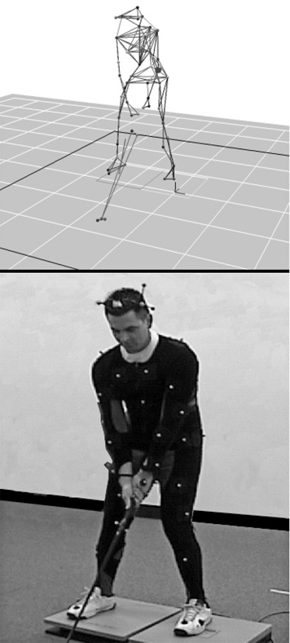

**Figure 16.21.** Optical motion capture: markers at- tached to a performer’s body allow skeletal motion to be ex- tracted. *Image courtesy of Mo- tion Analysis Corp.*

# Physics-Based Animation

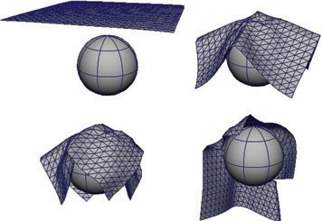

**Figure 16.22.** Realis- tic cloth simulation is often performed with physics-based methods. In this example, forces are due to collisions and gravity.

The world around us is governed by physical laws, many of which can be for- malized as sets of partial or, in some simpler cases, ordinary differential equa- tions. One of the original applications of computers was (and remains) solving such equations. It is therefore only natural to attempt to use numerical techniques developed over the several past decades to obtain realistic motion for computer animation.

Because of its relative complexity and significant cost, physics-based anima- tion is most commonly used in situations when other techniques are either un- available or do not produce sufficiently realistic results. Prime examples include animation of fluids (which includes many gaseous phase phenomena described by the same equations—smoke, clouds, fire, etc.), cloth simulation (an exam- ple is shown in Figure 16.22), rigid body motion, and accurate deformation of elastic objects. Governing equations and details of commonly used numerical approaches are different in each of these cases, but many fundamental ideas and difficulties remain applicable across applications. Many methods for numerically solving ODEs and PDEs exist, but discussing them in details is far beyond the scope of this book. To give the reader a flavor of physics-based techniques and some of the issues involved, we will briefly mention here only the finite differ- ence approach—one of the conceptually simplest and most popular families of algorithms which has been applied to most, if not all, differential equations en- countered in animation.

The key idea of this approach is to replace a differential equation with its dis- crete analog—a difference equation. To do this, the continuous domain of interest is represented by a finite set of points at which the solution will be computed. In the simplest case, these are defined on a uniform rectangular grid as shown in Fig- ure 16.23. Every derivative present in the original ODE or PDE is then replaced by its approximation through function values at grid points. One way of doing this is to subtract the function value at a given point from the function value for its neighboring point on the grid:

*df* (*t*) Δ*f*

*≈*

= *f* (*t* + Δ*t*) *− f* (*t*) or *∂f*(*x, t*) *≈* Δ*f*

= *f* (*x* + Δ*x, t*) *− f* (*x, t*) *.*

*dt* Δ*t* Δ*t*

*∂x* Δ*x*

Δ*x*

(16.2)

These expressions are, of course, not the only way. One can, for example, use *f* (*t −* Δ*t*) instead of *f* (*t*) above and divide by 2Δ*t*. For an equation containing a time derivative, it is now possible to propagate values of an unknown function

forward in time in a sequence of Δ*t*-size steps by solving the system of difference equations (one at each spatial location) for unknown *f* (*t* + Δ*t*). Some initial

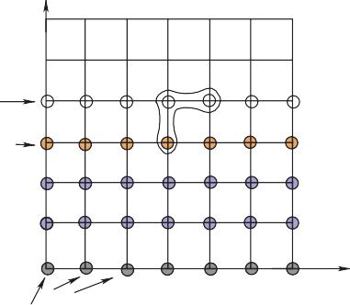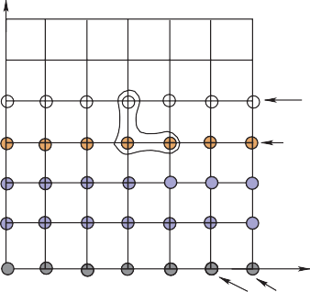

*t* + Δ*t*

Current

*x x* + Δ*x*

*x x* + Δ*x*

*t* = 0, Initial conditions

**Figure 16.23.** Two possible difference schemes for an equation involving derivatives *∂f/∂x* and

*∂f/∂t*. (Left) An explicit scheme expresses unknown values (open circles) only through known values at the current (orange circles) and possibly past (blue circles) time; (Right) Implicit schemes mix known and unknown values in a single equation making it necessary to solve all such equations as a system. For both schemes, information about values on the right boundary is needed to close the process.

conditions, i.e., values of the unknown function at *t* = 0, are necessary to start the process. Other information, such as values on the boundary of the domain, might also be required depending on the specific problem.

The computation of *f* (*t*+Δ*t*) can be done easily for so-called *explicit* schemes when all other values present are taken at the current time and the only unknown in the corresponding difference equation *f* (*t* + Δ*t*) is expressed through these known values. *Implicit* schemes mix values at current and future times and might use, for example,

*f* (*x* + Δ*x, t* + Δ*t*) *− f* (*x, t* + Δ*t*)

Δ*x*

as an approximation of *∂f* . In this case one has to solve a system of algebraic

*∂x*

equations at each step.

The choice of difference scheme can dramatically affect all aspects of the algorithm. The most obvious among them is *accuracy*. In the limit Δ*t →* 0

or Δ*x →* 0, expressions of the type in Equation (16.2) are exact, but for finite

step size some schemes allow better approximation of the derivative than others.

*Stability* of a difference scheme is related to how fast numerical errors, which are always present in practice, can grow with time. For stable schemes this growth is bounded, while for unstable ones it is exponential and can quickly overwhelm the solution one seeks (see Figure 16.24). It is important to realize that while some inaccuracy in the solution is tolerable (and, in fact, accuracy demanded in physics and engineering is rarely needed for animation), an unstable result is completely



*f* (*t*)

Unstable

Exact

Stable

*t*

**Figure 16.24.** An unstable solution might follow the ex- act one initially, but can devi- ate arbitrarily far from it with time. Accuracy of a stable solution might still be insuffi- cient for a specific application.

meaningless, and one should avoid using unstable schemes. Generally, explicit schemes are either unstable or can become unstable at larger step sizes while implicit ones are unconditionally stable. Implicit schemes allows greater step size (and, therefore, fewer steps) which is why they are popular despite the need to solve a system of algebraic equations at each step. Explicit schemes are attractive because of their simplicity if their stability conditions can be satisfied. Developing a good difference scheme and corresponding algorithm for a specific problem is not easy, and for most standard situations it is well advised to use an existing method. Ample literature discussing details of these techniques is available.

One should remember that, in many cases, just computing all necessary terms in the equation is a difficult and time-consuming task on its own. In rigid body or cloth simulation, for example, most of the forces acting on the system are due to collisions among objects. At each step during animation, one therefore has to solve a purely geometric, but very nontrivial, problem of collision detection. In such conditions, schemes which require fewer evaluations of such forces might provide significant computational savings.

Although the result of solving appropriate time-dependant equations gives very realistic motion, this approach has its limitations. First of all, it is very hard to control the result of physics-based animation. Fundamental mathematical properties of these equations state that once the initial conditions are set, the solu- tion is uniquely defined. This does not leave much room for animator input and, if the result is not satisfactory for some reason, one has only a few options. They are mostly limited to adjusting initial condition used, changing physical properties of the system, or even modifying the equations themselves by introducing artificial terms intended to “drive” the solution in the direction the animator wants. Making such changes requires significant skill as well as understanding of the underlying physics and, ideally, numerical methods. Without this knowledge, the realism provided by physics-based animation can be destroyed or severe numerical prob- lems might appear.

# Procedural Techniques

Imagine that one could write (and implement on a computer) a mathematical func- tion which outputs precisely the desired motion given some animator guidance. Physics-based techniques outlined above can be treated as a special case of such an approach when the “function” involved is the procedure to solve a particular differential equation and “guidance” is the set of initial and boundary conditions, extra equation terms, etc.

However, if we are only concerned with the final result, we do not have to follow a physics-based approach. For example, a simple constant amplitude wave on the surface of a lake can be directly created by applying the function

*f* (**x***, t*) = *A* cos(*ωt −* **kx** + *φ*) with constant frequency *ω*, wave vector **k** and phase *φ* to get displacement at the 2D point **x** at time *t*. A collection of such

waves with random phases and appropriately chosen amplitudes, frequencies, and wave vectors can result in a very realistic animation of the surface of water with- out explicitly solving any fluid dynamics equations. It turns out that other rather simple mathematical functions can also create very interesting patterns or objects. Several such functions, most based on lattice noises, have been described in Sec- tion 11.5. Adding time dependance to these functions allows us to animate certain complex phenomena much easier and cheaper than with physics-based techniques while maintaining very high visual quality of the results. If *noise*(**x**) is the un- derlying pattern-generating function, one can create a time-dependant variant of it by moving the argument position through the lattice. The simplest case is motion with constant speed: *timenoise*(**x***, t*) = *noise*(**x** + **v***t*), but more complex motion through the lattice is, of course, also possible and, in fact, more common. One such path, a spiral, is shown in Figure 16.25. Another approach is to animate pa-

rameters used to generate the *noise* function. This is especially appropriate if the appearance changes significantly with time—a cloud becoming more turbulent, for example. In this way one can animate the dynamic process of formation of clouds using the function which generates static ones.

For some procedural techniques, time dependance is a more integral compo- nent. The simplest *cellular automata* operate on a 2D rectangular grid where a binary value is stored at each location (cell). To create a time varying pat- tern, some user-provided rules for modifying these values are repeatedly applied. Rules typically involve some set of conditions on the current value and that of the cell’s neighbors. For example, the rules of the popular 2D *Game of Life* cel- lular automaton invented in 1970 by British mathematician John Conway are the following:

1. A dead cell (i.e., binary value at a given location is 0) with exactly three live neighbors becomes a live cell (i.e., its value set to 1).
2. A live cell with two or three live neighbors stays alive.
3. In all other cases, a cell dies or remains dead.

Once the rules are applied to all grid locations, a new pattern is created and a new evolution cycle can be started. Three sample snapshots of the live cell distri- bution at different times are shown in Figure 16.26. More sophisticated automata

*t* = 0

**Figure 16.25.** A path through the cube defining pro- cedural noise is traversed to animate the resulting pattern.

simultaneously operate on several 3D grids of possibly floating point values and can be used for modeling dynamics of clouds and other gaseous phenomena or biological systems for which this apparatus was originally invented (note the ter- minology). Surprising pattern complexity can arise from just a few well-chosen rules, but how to write such rules to create the desired behavior is often not obvi- ous. This is a common problem with procedural techniques: there is only limited, if any, guidance on how to create new procedures or even adjust parameters of existing ones. Therefore, a lot of tweaking and learning by trial-and-error (“by experience”) is usually needed to unlock the full potential of procedural methods.

Another interesting approach which was also originally developed to describe biological objects is the technique called *L-systems* (after the name of their origi- nal inventor, Astrid Lindenmayer). This approach is based on *grammars* or sets of recursive rules for rewriting strings of symbols. There are two types of symbols: *terminal symbols* stand for elements of something we want to represent with a grammar. Depending on their meaning, grammars can describe structure of trees and bushes, buildings and whole cities, or programming and natural languages. In animation, L-systems are most popular for representing plants and correspond- ing terminals are instructions to the geometric modeling system: put a leaf (or a branch) at a current position—we will use the symbol @ and just draw a circle,

move current position forward by some number of units (symbol *f* ), turn current

direction 60 degrees around world *Z*-axis (symbol +), pop (symbol [) or push (symbol ]) current position/orientation, etc. Auxiliary *nonterminal symbols* (de- noted by capital letters) have only semantic rather than any direct meaning. They are intended to be eventually rewritten through terminals. We start from the spe- cial nonterminal start symbol *S* and keep applying grammar rules to the current string in parallel, i.e., replace all nonterminals currently present to get the new

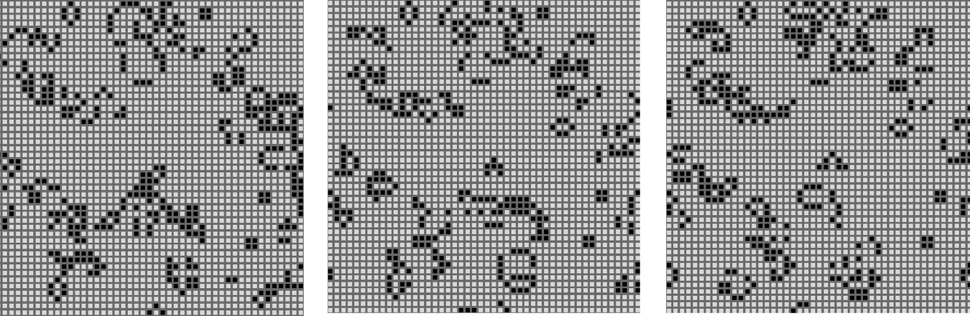

**Figure 16.26.** Several (non-consecutive) stages in the evolution of a *Game of Life* automaton. Live cells are shown in black. Stable objects, oscillators, traveling patterns, and many other interesting constructions can result from the application of very simple rules. *Figure created using a program by Alan Hensel.*

string, until we end up with a string containing only terminals and no more sub- stitution is therefore possible. This string of modeling instructions is then used to output the actual geometry. For example, a set of rules (productions)

*S → A*

*A →* [+*B*]*fA*

*A → B B → fB B → f* @

might result in the following sequence of rewriting steps demonstrated in Fig- ure 16.27:

*S ∗−→ A −→* [+*B*]*fA ∗−→* [+*fB*]*f* [+*B*]*fA ∗−→* [+*ff* @]*f* [+*fB*]*fB ∗−→* [+*ff* @]*f* [+*ff* @]*ff* @*.*

As shown above, there are typically many different productions for the same non- terminal allowing the generation of many different objects with the same gram- mar. The choice of which rule to apply can depend on which symbols are located next to the one being replaced (context-sensitivity) or can be performed at ran- dom with some assigned probability for each rule (stochastic L-systems). More complex rules can model interaction with the environment, such as pruning to a particular shape, and parameters can be associated with symbols to control geo- metric commands issued.

L-systems already capture plant topology changes with time: each interme- diate string obtained in the rewriting process can be interpreted as a “younger” version of the plant (see Figure 16.27). For more significant changes, different productions can be in effect at different times allowing the structure of the plant to change significantly as it grows. A young tree, for example, produces a lot of new branches, while an older one branches only moderately.

Very realistic plant models have been created with L-systems. However, as with most procedural techniques, one needs some experience to meaningfully apply existing L-systems, and writing new grammars to capture some desired effect is certainly not easy.

# Groups of Objects

To animate multiple objects one can, of course, simply apply standard techniques described in the chapter so far to each of them. This works reasonably well for a moderate number of independent objects whose desired motion is known in

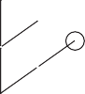

*S*

*A*

*A*

*A*

*B*

*B*

*B*

*B*

*B*

**Figure 16.27.** Consecutive derivation steps using a sim- ple L-system. Capital letters denote nonterminals and illus- trate positions at which corre- sponding nonterminal will be expanded. They are not part of the actual output.

advance. However, in many cases, some kind of coordinated action in a dynamic environment is necessary. If only a few objects are involved, the animator can use an artificial intelligence (AI)-based system to automatically determine immediate tasks for each object based on some high-level goal, plan necessary motion, and execute the plan. Many modern games use such *autonomous objects* to create smart monsters or player’s collaborators.

Interestingly, as the number of objects in a group grows from just a few to several dozens, hundreds, and thousands, individual members of a group must have only very limited “intelligence” in order for the group as a whole to exhibit what looks like coordinated goal-driven motion. It turns out that this *flocking* is *emergent behavior* which can arise as a result of limited interaction of group members with just a few of their closest neighbors (Reynolds, 1987). Flocking should be familiar to anyone who has observed the fascinatingly synchronized motion of a flock of birds or a school of fish. The technique can also be used to control groups of animals moving over terrain or even a human crowd.

At any given moment, the motion of a member of a group, often called boid when applied to flocks, is the result of balancing several often contradictory ten- dencies, each of which suggests its own velocity vector (see Figure 16.28). First, there are external physical forces *F* acting on the boid, such as gravity or wind. New velocity due to those forces can be computed directly through Newton’s law as

***v****physics* = ***v****old* + ***F***Δ*t/m.*

*new*

Collision avoidance Physical forces

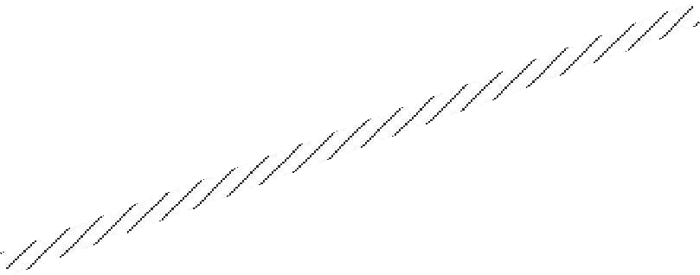

Flock centering

Collision avoidance

Velocity matching Goal

Gravity



Goal

Steering

Navigation module

Physical constraints



Desired velocity

Feasible velocity

Pilot module

Flight module

Boid control adjustments

**Figure 16.28.** (Left) Individual flock member (boid) can experience several urges of different importance (shown by line thickness) which have to be negotiated into a single velocity vector. A boid is aware of only its limited neighborhood (circle). (Right) Boid control is commonly implemented as three separate modules.

Second, a boid should react to global environment and to the behavior of other group members. Collision avoidance is one of the main results of such interac- tion. It is crucial for flocking that each group member has only limited field of view, and therefore is aware only of things happening within some neighborhood of its current position. To avoid objects in the environment, the simplest, if imper- fect, strategy is to set up a limited extent repulsive force field around each such object. This will create a second desired velocity vector ***v****col avoid*, also given by Newton’s law. Interaction with other group members can be modeled by si- multaneously applying different steering behaviors resulting in several additional desired velocity vectors ***v****steer*. Moving away from neighbors to avoid crowding, steering toward flock mates to ensure flock cohesion, and adjusting a boid’s speed to align with average heading of neighbors are most common. Finally, some addi- tional desired velocity vectors ***v****goal* are usually applied to achieve needed global goals. These can be vectors along some path in space, following some specific designated leader of the flock, or simply representing migratory urge of a flock member.

*new*

*new*

*new*

Once all ***v****new* are determined, the final desired vector is negotiated based on

priorities among them. Collision avoidance and velocity matching typically have higher priority. Instead of simple averaging of desired velocity vectors which can lead to cancellation of urges and unnatural “moving nowhere” behavior, an ac- celeration allocation strategy is used. Some fixed total amount of acceleration is made available for a boid and fractions of it are being given to each urge in order of priority. If the total available acceleration runs out, some lower priority urges will have less effect on the motion or be completely ignored. The hope is that once the currently most important task (collision avoidance in most situations) is accomplished, other tasks can be taken care of in near future. It is also important to respect some physical limitations of real objects, for example, clamping too high accelerations or speeds to some realistic values. Depending on the internal complexity of the flock member, the final stage of animation might be to turn the negotiated velocity vector into a specific set of parameters (bird’s wing positions, orientation of plane model in space, leg skeleton bone configuration) used to con- trol a boid’s motion. A diagram of a system implementing flocking is shown on Figure 16.28 (right).

A much simpler, but still very useful, version of group control is implemented

by *particle systems* (Reeves, 1983). The number of particles in a system is typi- cally much larger than number of boids in a flock and can be in the tens or hun- dreds of thousands, or even more. Moreover, the exact number of particles can fluctuate during animation with new particles being born and some of the old ones destroyed at each step. Particles are typically completely independent from

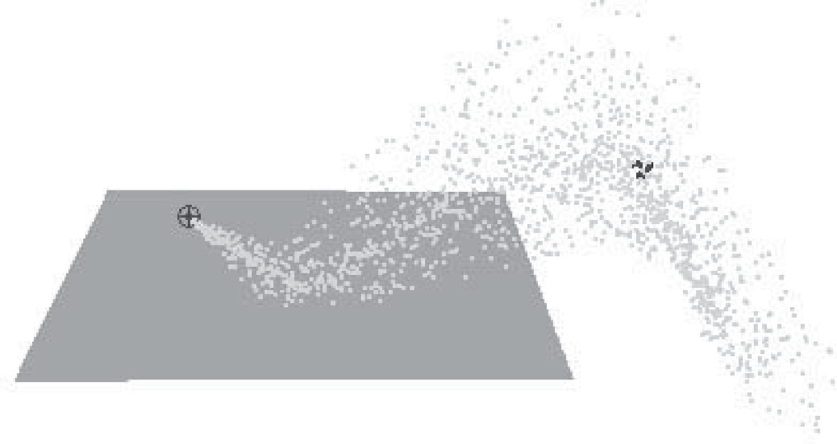

Local wind field

Particle source

**Figure 16.29.** After being emitted by a directional source, particles collide with an object and then are blown down by a local wind field once they clear the obstacle.

each other, ignoring one’s neighbors and interacting with the environment only by experiencing external forces and collisions with objects, *not* through collision avoidance as was the case for flocks. At each step during animation, the sys- tem first creates new particles with some initial parameters, terminates old ones, and then computes necessary forces and updates velocities and positions of the remaining particles according to Newton’s law.

All parameters of a particle system (number of particles, particle life span, initial velocity, and location of a particle, etc.) are usually under the direct control of the animator. Prime applications of particle systems include modeling fire- works, explosions, spraying liquids, smoke and fire, or other fuzzy objects and phenomena with no sharp boundaries. To achieve a realistic appearance, it is im- portant to introduce some randomness to all parameters, for example, having a random number of particles born (and destroyed) at each step with their velocities generated according to some distribution. In addition to setting appropriate initial parameters, controlling the motion of a particle system is commonly done by cre- ating a specific force pattern in space—blowing a particle in a new direction once it reaches some specific location or adding a center of attraction, for example. One should remember that with all their advantages, simplicity of implementa- tion and ease of control being the prime ones, particle systems typically do not provide the level of realism characteristic of true physics-based simulation of the same phenomena.

# Notes

In this chapter we have concentrated on techniques used in 3D animation. There also exist a rich set of algorithms to help with 2D animation production and post-

processing of images created by computer graphics rendering systems. These include techniques for cleaning up scanned-in artist drawings, feature extrac- tion, automatic 2D in-betweening, colorization, image warping, enhancement and compositing, and many others.

One of the most significant developments in the area of computer animation has been the increasing power and availability of sophisticated animation systems. While different in their specific set of features, internal structure, details of user interface, and price, most such systems include extensive support not only for animation, but also for modeling and rendering, turning them into complete pro- duction platforms. It is also common to use these systems to create still images. For example, many images for figures in this section were produced using Maya software generously donated by Alias.

Large-scale animation production is an extremely complex process which typ- ically involves a combined effort by dozens of people with different backgrounds spread across many departments or even companies. To better coordinate this ac- tivity, a certain production pipeline is established which starts with a story and character sketches, proceeds to record necessary sound, build models, and rig characters for animation. Once actual animation commences, it is common to go back and revise the original designs, models, and rigs to fix any discovered motion and appearance problems. Setting up lighting and material properties is then necessary, after which it is possible to start rendering. In most sufficiently complex projects, extensive postprocessing and compositing stages bring together images from different sources and finalize the product.

We conclude this chapter by reminding the reader that in the field of computer animation, any technical sophistication is secondary to a good story, expressive characters, and other artistic factors, most of which are hard or simply impossible to quantify. It is safe to say that Snow White and her seven dwarfs will always share the screen with green ogres and donkeys, and most of the audience will be much more interested in the characters and the story rather than in which, if any, computers (and in what exact way) helped to create them.